

**KING’S OWN INSTITUTE\***

**Success in Higher Education**

# INDIVIDUAL ASSIGNMENT COVERSHEET

Family Name: AUSTRIA Given Name: JOHN BENNY

Student Number: 12301175 Lecturer’s Name: MOHAMAD NAJI

Subject Name: ICT702: Introduction to Database Design

Assignment Title: Assessment 4: Individual Database Assessment

**Declaration**

(This declaration must be completed by the student or the assignment will not be marked.)

I certify the following:

* I have read and understood the *Student Academic Misconduct Policy*
* This assignment is my own work based on my personal study and or research.
* I have acknowledged all material and sources used in the preparation of this assignment including any material generated in the course of my employment.
* The assignment has not previously been submitted for assessment.
* I have not copied in part or in whole or otherwise plagiarised the work of other students.
* I have read and I understand the criteria used for assessment.
* The assignment is within the word and page limits specified in the unit outline.
* The use of any material in this assignment does not infringe the intellectual property / copyright of a third party.
* I understand that this assignment may undergo electronic detection for plagiarism, and an anonymous copy of the assignment may be retained on the database and used to make comparisons with other assignments in future.
* By completing this coversheet in full and submitting this assignment electronically, I am bound by the conditions of the KOI’s *Student Academic Misconduct Policy* and the declaration on this coversheet.



10 / 09 / 2023

Signature Date

----------------------------------------------------------------------------

**Assignment Receipt**

Family Name: AUSTRIA Student Number: 12301175

Given Name:(s) JOHN BENNY

Lecturer’s Name: MOHAMAD NAJI

Subject Name: ICT702: Introduction to Database Design

Assignment Title: Assessment 4: Individual Database Assessment



10 / 09 / 2023

Signature Date

INDIVIDUAL ASSIGNMENT COVER SHEET * AUSTRALIAN INSTITUTE OF BUSINESS AND MANAGEMENT PTY LTD PAGE **1** OF **1**

13 JULY 2015 CRICOS 03171A ABN: 72 132 629

# EXECUTIVE SUMMARY

The focus of the case study is a company called "Toys for You to Home Delivery," which sells a range of toys over the phone and on its website. In addition to having distribution centres in several states, the business operates across Australia. A unique identity, manager information, and logistical information are all included in every warehouse. Employee information, including that of workers, drivers, and assistants, as well as their pertinent certificates and licenses, is also kept on file.

From small vans to larger trucks, the warehouses are in charge of a fleet of transport vehicles with various characteristics. For delivery to be possible, customers must register for an account and obtain a paid invoice. The products are included on the invoice and their respective descriptions and prices. After payment is received, one or more delivery requests are produced and must be fulfilled.

Entity-relationship (ER) models, adhering to the third standard form, with distinct subtype entities, must be created for the case study. The ER diagram must use Crow's Foot notation and adhere to the guidelines established by Michael L. Hernandez (4th edition). In addition, students must use XAMPP to build a database and supply Data Definition Language (DDL) instructions. Data Manipulation Language (DML) statements of at least three rows of data will be used to populate the database. This will ensure the tables accurately represent the inserted information.

In summary, this case study covers the creation of a thorough database system to effectively handle the business operations of Toys for You to Home Delivery, including information on warehouses, personnel, vehicles, clients, bills, and delivery requests. This project's essential elements are the ER model, database setup, DDL, and DML commands.

# TABLE OF CONTENTS

INDIVIDUAL ASSIGNMENT COVERSHEET 1

EXECUTIVE SUMMARY 2

TABLE OF CONTENTS 3

1.0 ASSUMPTIONS 4

2.0 ENTITIES 4

2.1 STRONG ENTITIES 4

2.2 WEAK ENTITIES 5

3.0 ENTITIES WITH THEIR ATTRIBUTES INCLUDING PRIMARY KEYS AND FOREIGN KEYS NORMALISED IN 3RD NORMAL FORM 5

3.1 WAREHOUSE 5

3.2 MANAGER 5

3.3 MANAGER_TITLE 6

3.4 DRIVER_LICENSE 6

3.5 EMPLOYEE 6

3.6 WORKER 7

3.7 DRIVER 7

3.8 JOCKEY 7

3.9 TRANSPORT_VEHICLE 7

3.10 VAN 8

3.11 TRUCK 8

3.12 CUSTOMER 8

3.13 INVOICE 9

3.14 LINE_ITEM 9

3.15 PRODUCT 9

3.16 DELIVERY_REQUEST 9

3.17 ADDRESS 10

3.18 PAYMENT 10

4.0 RELATIONSHIP AMONG ENTITIES 11

5.0 ENTITY RELATIONS, CARDINALITIES, AND CONNECTIVITY’S 12

6.0 ERD DIAGRAM 23

7.0 DATA DICTIONARY 24

8.0 TABLES WITH DATA FOR EACH ATTRIBUTE 30

9.0 DDL STATEMENTS 38

10.0 DML STATEMENTS 47

11.0 REFERENCES 61

# 1.0 ASSUMPTIONS

The database's structure includes tables for various delivery management system elements. The following assumptions are made:

* It is expected that the data entered into the system is correct and trustworthy.
* Assume that all characteristics, including names and nicknames, of entities covered by the database are handled as functional dependents of the entity. Although there may be quality control procedures in place, the database assumes that data integrity is at least minimal.
* The database assumes that any consumer who wants to buy something will register an account. Guest checkouts should be taken into consideration.
* It is expected that customers' delivery instructions are precise and understandable. Uncertain instructions could be subject to a process for clarification.

These assumptions are secure since they constitute a crucial component of sound database architecture.

# 2.0 ENTITIES

An entity in a database is an item, place, person, or object that exists independently of another. All databases are built on commodities, which store data globally. Entities are also helpful for modelling and managing client data, corporate data, and personal records (Harrington, 2016).

## 2.1 STRONG ENTITIES

* 1. WAREHOUSE
  2. MANAGER
  3. EMPLOYEE
  4. WORKER
  5. DRIVER
  6. JOCKEY
  7. TRANSPORT_VEHICLE
  8. VAN
  9. TRUCK
  10. CUSTOMER
  11. ADDRESS

## 2.2 WEAK ENTITIES

* 1. INVOICE
  2. LINE_ITEM
  3. PRODUCT
  4. DELIVERY_REQUEST
  5. MANAGER_TITLE
  6. DRIVER_LICENSE
  7. PAYMENT

# 3.0 ENTITIES WITH THEIR ATTRIBUTES INCLUDING PRIMARY KEYS AND FOREIGN KEYS NORMALISED IN 3RD NORMAL FORM

Since they aid in defining the data structure in a database, attributes are crucial to DBMS. Data organization and meaningful querying would be challenging without the attributes. The 3NF ensures every non-key attribute of a table solely depends on its primary key to function, thus enhancing data consistency and integrity (Amin et al., 2019).

## 3.1 WAREHOUSE

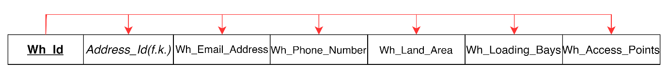

FD1: **Wh_Id** → *Address_Id(f.k.),* Wh_Email_Address Wh_Phone_Number, Wh_LandArea, Wh_Loading_Bays, Wh_Access_Points [3NF, Full Dependency]

**WAREHOUSE**  (**Wh_Id,** *Address_Id(f.k.),* Wh_Email_Address Wh_Phone_Number, Wh_LandArea, Wh_Loading_Bays, Wh_Access_Points)

## 3.2 MANAGER



FD1: **Mgr_Id** →*Wh_Id(f.k.),Mgr_Title(f.k.) Driver_License_Number(f.k.)* Mgr_First_Name, Mgr_Last_Name, Mgr_Contact_Number, Mgr_Email_Address, Mgr_Start_Date, Mgr_Termination_Date [3NF, Full Dependency]

**MANAGER** (**Mgr_Id*,*** *Wh_Id(f.k.),Mgr_Title(f.k.) Driver_License_Number(f.k.)* Mgr_First_Name, Mgr_Last_Name, Mgr_Contact_Number, Mgr_Email_Address, Mgr_Start_Date, Mgr_Termination_Date)

## 3.3 MANAGER_TITLE

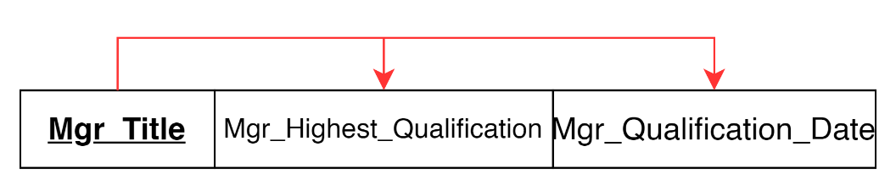

FD1: **Mgr_Title** → Mgr_Highest_Qualification, Mgr_Qualification_Date [3NF, Full Dependency]

**MANAGER_TITLE** (**Mgr_Title**, Mgr_Highest_Qualification, Mgr_Qualification_Date)

## 3.4 DRIVER_LICENSE

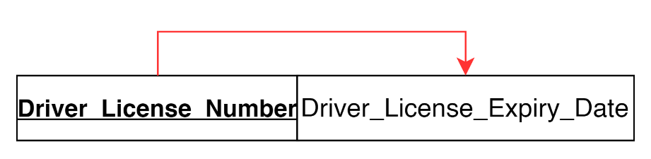

FD1: **Driver_License_Number** → Driver_License_Expiry_Date [3NF, Full Dependency]

**DRIVER_LICENSE** (**Driver_License_Number**, Driver_License_Expiry_Date)

## 3.5 EMPLOYEE



FD1: **Emp_Id** → *Wh_Id(f.k.),Mgr_Id(f.k.), Driver_License_Number(f.k.)* Emp_First_Name, Emp_Last_Name, Emp_Contact_Number, Emp_Email_Address, Emp_Start_Date, Emp_Termination_Date, Emp_Type [3NF, Full Dependency]

**EMPLOYEE** (**Emp_Id**, *Wh_Id(f.k.),Mgr_Id(f.k.), Driver_License_Number(f.k.)* Emp_First_Name, Emp_Last_Name, Emp_Contact_Number, Emp_Email_Address, Emp_Start_Date, Emp_Termination_Date, Emp_Type)

## 3.6 WORKER

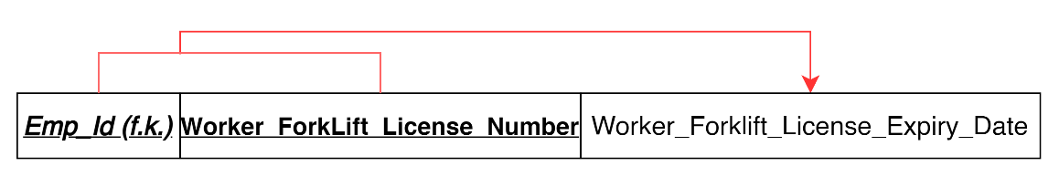

FD1: **(*Emp_Id (fk),* Worker_Forklift_License_Number)** → Worker_Forklift_License_Expiry_Date [3NF, Full Dependency]

**WORKER**  (***Emp_Id (fk),* Worker_Forklift_License_Number**, Worker_Forklift_License_Expiry_Date)

## 3.7 DRIVER

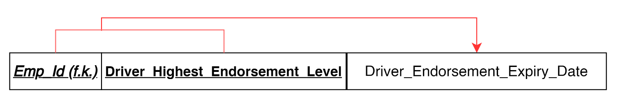

FD1: (***Emp_Id (fk),* Driver_Highest_Endorsement_Level)** → Driver_Endorsement_Expiry_Date [3NF, Full Dependency]

**DRIVER**  (***Emp_Id (fk),* Driver_Highest_Endorsement_Level,** Driver_Endorsement_Expiry_Date)

## 3.8 JOCKEY

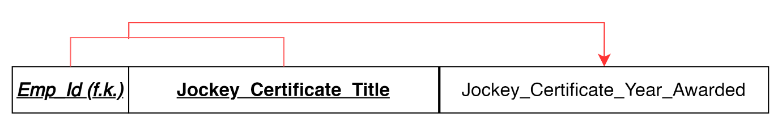

FD1: **(*Emp_Id (fk),* Jockey_Certificate_Title)** → Jockey_Certificate_Year_Awarded [3NF, Full Dependency]

**JOCKEY** (***Emp_Id (fk),* Jockey_Certificate_Title**, Jockey_Certificate_Year_Awarded)

## 3.9 TRANSPORT_VEHICLE



FD1: **Registration_Number** → *Wh_Id(f.k.),* *Emp_Id (fk), Driver_Highest_Endorsement_Level (f.k.),*Seating_Capacity, Carrying_Capacity, GVM, Kerb_Weight, Load_Space_Cubic_Metres, Max_Load_Area_Height, Max_Load_Area_Width, Max_Load_Area_Depth, Status, Vehicle_Type [3NF, Full Dependency]

**TRANSPORT_VEHICLE** (**Registration_Number** *Wh_Id(f.k.),* *Emp_Id (fk), Driver_Highest_Endorsement_Level (f.k.),*Seating_Capacity, Carrying_Capacity, GVM, Kerb_Weight, Load_Space_Cubic_Metres, Max_Load_Area_Height, Max_Load_Area_Width, Max_Load_Area_Depth, Status, Vehicle_Type)

## 3.10 VAN

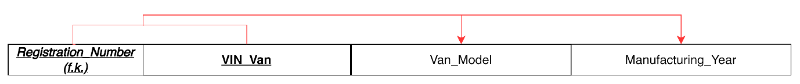

FD1: **(*Registration_Number (fk),* VIN_Van** → Van_Model, Manufacturing_Year [3NF, Full Dependency]

**VAN** (***Registration_Number (fk),* VIN_Van,** Van_Model, Manufacturing_Year)

## 3.11 TRUCK

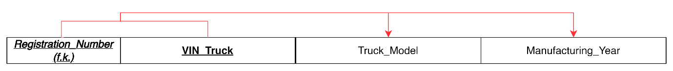

FD1: **(*Registration_Number(fk),* VIN_Truck** → Truck_Model, Manufacturing_Year [3NF, Full Dependency]

**TRUCK** (***Registration_Number(fk),* VIN_Truck,** Truck_Model, Manufacturing_Year)

## 3.12 CUSTOMER

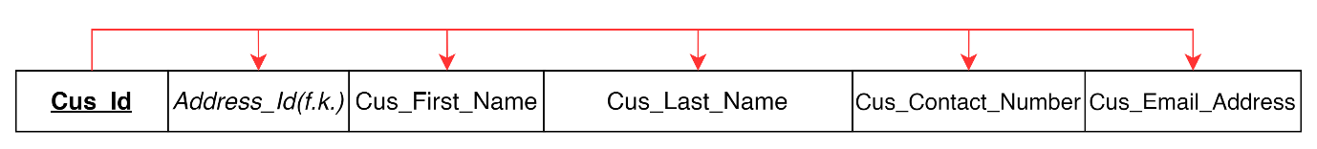

FD1: **Cus_Id** →*Address_Id (f.k.),* Cus_First_Name, Cus_Last_Name, Cus_Contact_Number, Cus_Email_Address [3NF, Full Dependency]

**CUSTOMER** (**Cus_Id,** *Address_Id (f.k.),* Cus_First_Name, Cus_Last_Name, Cus_Contact_Number, Cus_Email_Address)

## 3.13 INVOICE

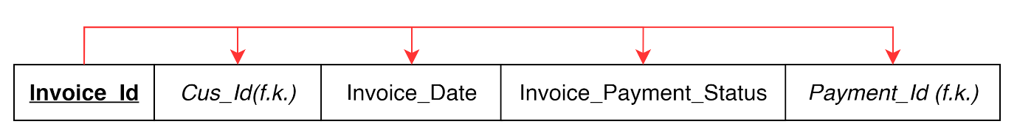

FD1: **Invoice_Id** → *Cus_Id(f.k.),* Invoice_Date, Invoice_Payment_Status, *Payment_Id (f.k.)* [3NF, Full Dependency]

**INVOICE** (**Invoice_Id,** *Cus_Id(f.k.),* Invoice_Date, Invoice_Payment_Status, *Payment_Id(f.k.)*)

## 3.14 LINE_ITEM

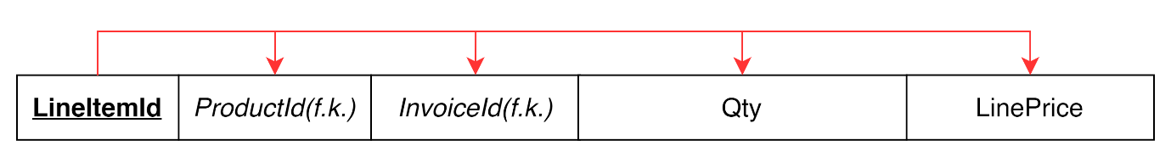

FD1: **Line_Item_Id** → *Product_Id(f.k.),**Invoice_Id(f.k.),* Qty, Line_Price [3NF, Full Dependency]

**LINE_ITEM**  (**Line_Item_Id,** *Product_Id(f.k.),**Invoice_Id(f.k.),* Qty, Line_Price)

## 3.15 PRODUCT

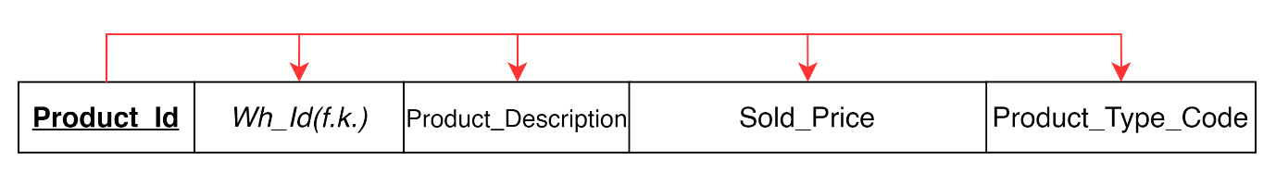

FD1: **Product_Id** →*Wh_Id(f.k.),* Product_Description, Sold_Price, Product_Type_Code [3NF, Full Dependency]

**PRODUCT** (**Product_Id,** *Wh_Id(f.k.),* Product_Description, Sold_Price, Product_Type_Code)

## 3.16 DELIVERY_REQUEST



FD1: **Delivery_Id** → Request_Date, Requested_Delivery_Date, Actual_Delivery_Date, Delivery_Contact_Name, Delivery_Phone_Number, Delivery_Instructions, *Invoice_Id(f.k.), Wh_Id(f.k.)*, *Address_Id (f.k.), Cus_Id (f.k.), Emp_Id (f.k.), Registration_Number (f.k.)* [3NF, Full Dependency]

**DELIVERY_REQUEST** (**Delivery_Id,** Request_Date, Requested_Delivery_Date, Actual_Delivery_Date, Delivery_Contact_Name, Delivery_Phone_Number, Delivery_Instructions, *Invoice_Id(f.k.), Wh_Id(f.k.)*, *Address_Id (f.k.), Cus_Id (f.k.), Emp_Id (f.k.), Registration_Number (f.k.)*)

## 3.17 ADDRESS

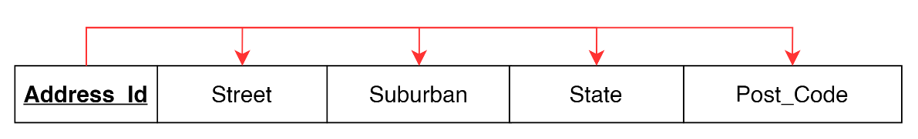

FD1: **Address_Id** → Street, Suburban, State, Post_Code [3NF, Full Dependency]

**ADDRESS** (**Address_Id,** Street, Suburban, State, Post_Code)

## 3.18 PAYMENT

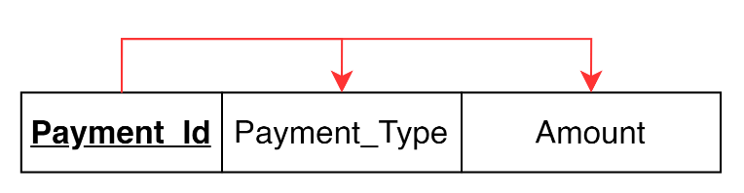

FD1: **Payment_Id** → Payment_Type, Amount [3NF, Full Dependency]

**PAYMENT** (**Payment_Id,** Payment_Type, Amount)

# 4.0 RELATIONSHIP AMONG ENTITIES

The thing that binds the tables together is relationships. They are employed to link relevant data between tables.

1. WAREHOUSE and ADDRESS: WAREHOUSE is related to ADDRESS as WAREHOUSE is located in an ADDRESS.
2. WAREHOUSE and MANAGER: WAREHOUSE is related to MANAGER as warehouse employs manager and manager manages the warehouse.
3. WAREHOUSE and EMPLOYEE: WAREHOUSE is related to EMPLOYEE as warehouse employs employees and employees works in the warehouse.
4. WAREHOUSE and TRANSPORT_VEHICLE: WAREHOUSE is related to TRANSPORT_VEHICLE as warehouse maintain and regularly service transport vehicles. Each transport vehicles are assigned to one warehouse.
5. WAREHOUSE and DELIVERY_REQUEST: WAREHOUSE is related to DELIVERY_REQUEST as warehouse handles the delivery request and delivery request is allocated by the warehouse.
6. WAREHOUSE and PRODUCT: WAREHOUSE is related to PRODUCT as warehouse manufactures the product and product is stored in the warehouse.
7. MANAGER and EMPLOYEE: MANAGER is related to EMPLOYEE as manager manages the employee and employee reports to the manager.
8. MANAGER and MANAGER_TITLE: MANAGER is related to MANAGER_TITLE as manager holds the position of the manager title.
9. MANAGER and DRIVER_LICENSE: MANAGER is related to DRIVER_LICENSE as manager needs to have a driver license to work in the warehouse.
10. EMPLOYEE and DRIVER_LICENSE: EMPLOYEE is related to DRIVER_LICENSE as employee needs to possess a driver license to be able to work in the warehouse.
11. EMPLOYEE and DRIVER: EMPLOYEE is related to DRIVER as driver is a subtype of employee.
12. EMPLOYEE and JOCKEY: EMPLOYEE is related to JOCKEY as jockey is a subtype of employee.
13. EMPLOYEE and WORKER: EMPLOYEE is related to WORKER as worker is a subtype of employee.
14. DRIVER and TRANSPORT_VEHICLE: DRIVER is related to TRANSPORT_VEHICLE as driver drives the transport vehicle to deliver products ordered by the customer. A transport vehicle is assigned to a driver.
15. TRANSPORT_VEHCILE and DELIVERY_REQUEST: TRANSPORT_VEHCILE is related to DELIVERY_REQUEST as transport vehicle transport the products from the delivery request. Delivery request records the delivery made from the transport vehicle.
16. TRANSPORT_VEHICLE and TRUCK: TRANSPORT_VEHICLE is related to TRUCK as truck is a subtype of the transport vehicle.
17. TRANSPORT_VEHICLE and VAN: TRANSPORT_VEHICLE is related to VAN as van is a subtype of the transport vehicle.
18. JOCKEY and DELIVERY_REQUEST: JOCKEY is related to DELIVERY_REQUEST as Jockey assists in the delivery.
19. DELIVERY_REQUEST and ADDRESS: DELIVERY_REQUEST is related to ADDRESS to know where the delivery is going to be made.
20. CUSTOMER and ADDRESS: CUSTOMER is related to ADDRESS as address identifies the location of the customer.
21. CUSTOMER and INVOICE: CUSTOMER is related to INVOICE as customer can obtain many invoices. Invoices keeps the purchases of the customer.
22. CUSTOMER and DELIVERY_REQUEST: CUSTOMER is related to DELIVERY_REQUEST as customer can make many delivery requests. Delivery request is generated upon the customer’s choice.
23. INVOICE and LINE_ITEM: INVOICE is related to LINE_ITEM as purchase line generates the invoice. Each invoice contains one or many purchase line.
24. INVOICE and DELIVERY_REQUEST: INVOICE is related to DELIVERY_REQUEST as invoice list down the request of customers in the delivery request.
25. INVOICE and PAYMENT: INOVOICE is related to PAYMENT as invoice determine whether a payment has been made or not.
26. LINE_ITEM and PRODUCT: LINE_ITEM is related to PRODUCT as purchase line records the quantity of products bought by the customer. Product describes the purchase line.

# 5.0 ENTITY RELATIONS, CARDINALITIES, AND CONNECTIVITY’S

The connectivity of the relationship describes the mapping of connected entity instances in a relationship. The number of related occurrences for each of the two things is the cardinality of a connection. Cardinality is crucial in databases because it establishes organized linkages between different tables or entities (Liddle et al., 1993).

1. 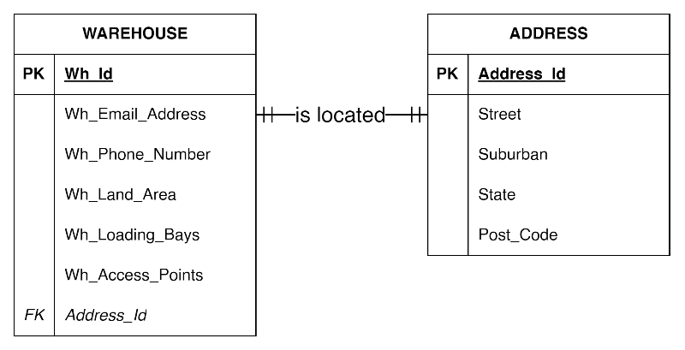

WAREHOUSE to ADDRESS: One-to-One Mandatory (1:1)

ADDRESS to WAREHOUSE: One-to-One Mandatory (1:1)

One warehouse must only be located in one address. (1, 1)

One address is only allocated for one warehouse. (1, 1)

1. 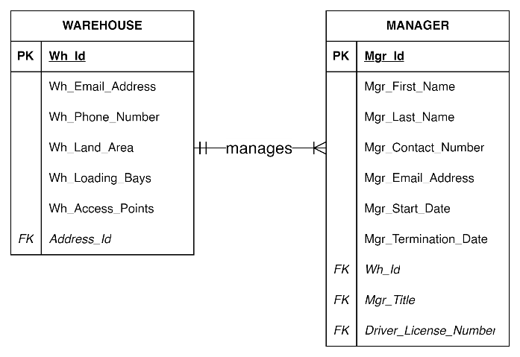

WAREHOUSE to MANAGER: One-to-Many Mandatory (1:M)

MANAGER to WAREHOUSE: One-to-One Mandatory (1:1)

Each warehouse is managed by one or more managers. (1, M)

Each manager can only manage one warehouse. (1, 1)

1. 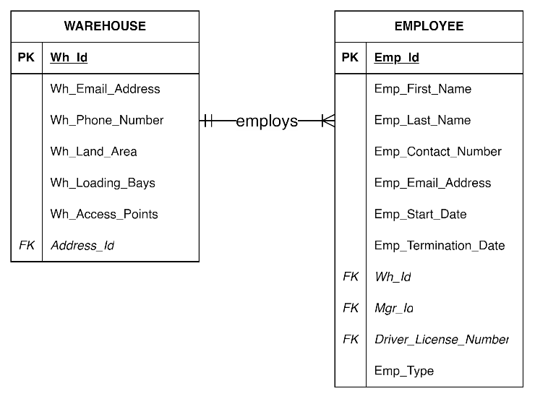

WAREHOUSE to EMPLOYEE: One-to-Many Mandatory (1:M)

EMPLOYEE to WAREHOUSE: One-to-One Mandatory (1:1)

Each warehouse can employ one or more employees. (1, M)

Each employee can only be employed by one warehouse. (1, 1)

1. 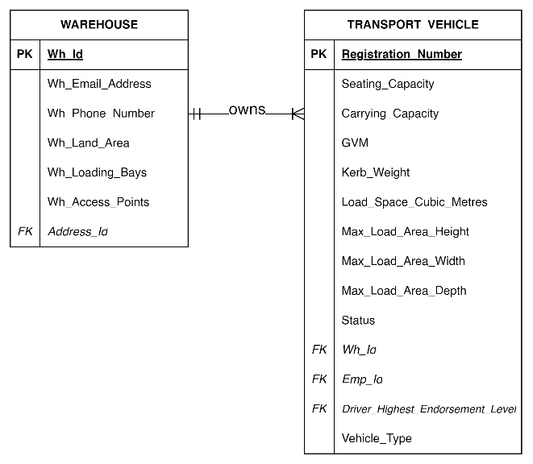

WAREHOUSE to TRANSPORT_VEHICLE: One-to-Many Mandatory (1:M)

TRANSPORT_VEHICLE to WAREHOUSE: One-to-One Mandatory (1:1)

Each warehouse can own one or many transport vehicles. (1, M)

Each transport vehicle belongs to one warehouse. (1, 1)

1. 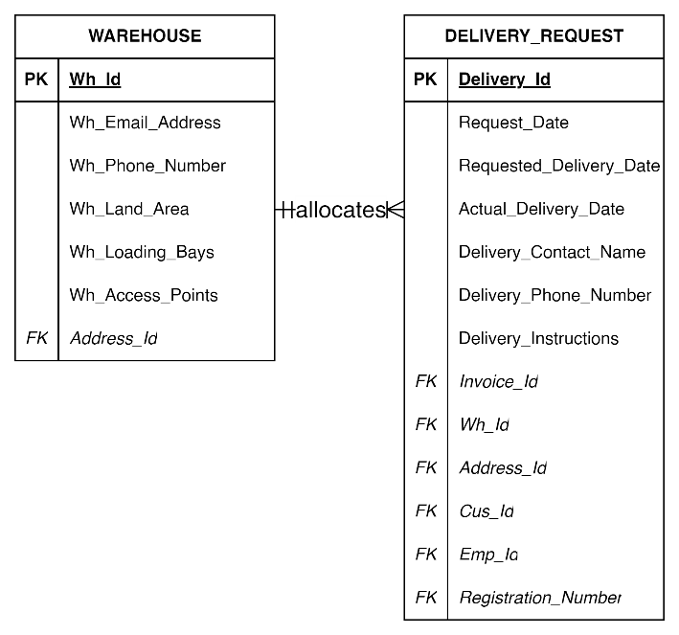

WAREHOUSE to DELIVERY_REQUEST: One-to-Many Mandatory (1:M)

DELIVERY_REQUEST to WAREHOUSE: One-to-One Mandatory (1:1)

Each warehouse can allocate one or many delivery requests. (1, M)

Each delivery request can only be allocated by one warehouse. (1, 1)

1. 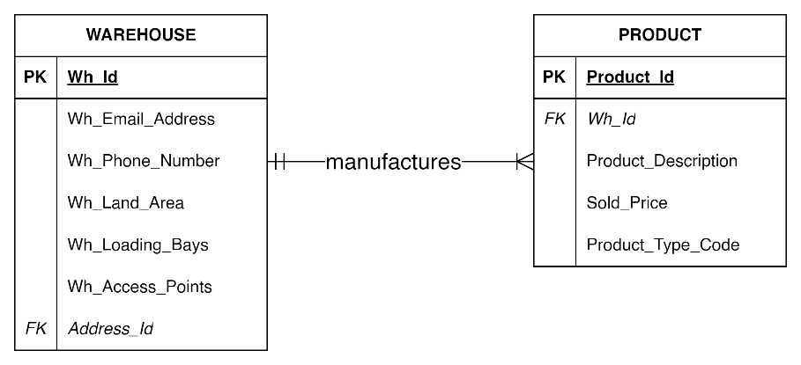

WAREHOUSE to PRODUCT: One-to-Many Mandatory (1:M)

PRODUCT to WAREHOUSE: One-to-One Mandatory (1:1)

One warehouse can manufacture one or many products. (1, M)

Each product can only be manufactured in one warehouse. (1, 1)

1. 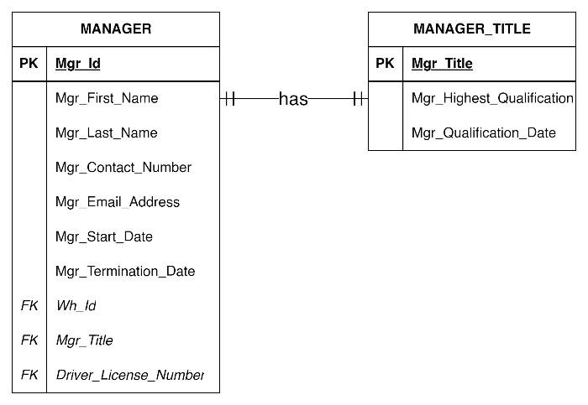

MANAGER to MANAGER_TITLE: One-to-One Mandatory (1:1)

MANAGER_TITLE to MANAGER: One-to-One Mandatory (1:1)

Each manager can only have only one manager title. (1, 1)

Each manager title can only be given to one manager. (1, 1)

1. 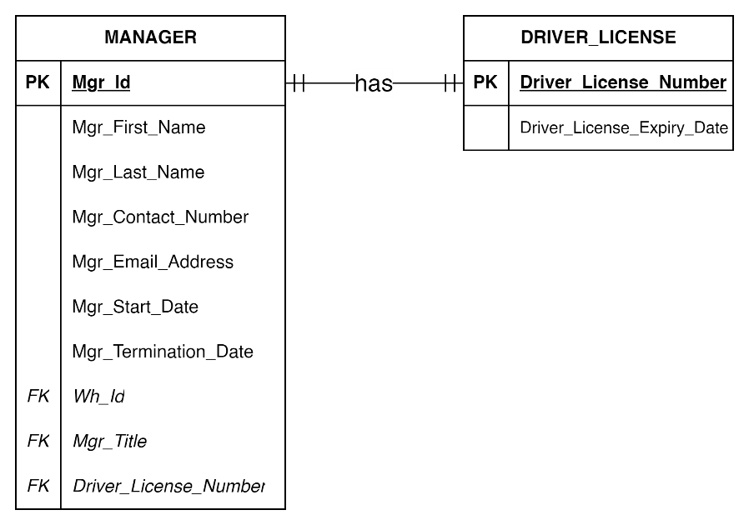

MANAGER to DRIVER_LICENSE: One-to-One Mandatory (1:1)

DRIVER_LICENSE to MANAGER: One-to-One Mandatory (1:1)

Each manager can only have on driver’s license. (1, 1)

Only one driver’s license can only be given to one manager. (1, 1)

1. 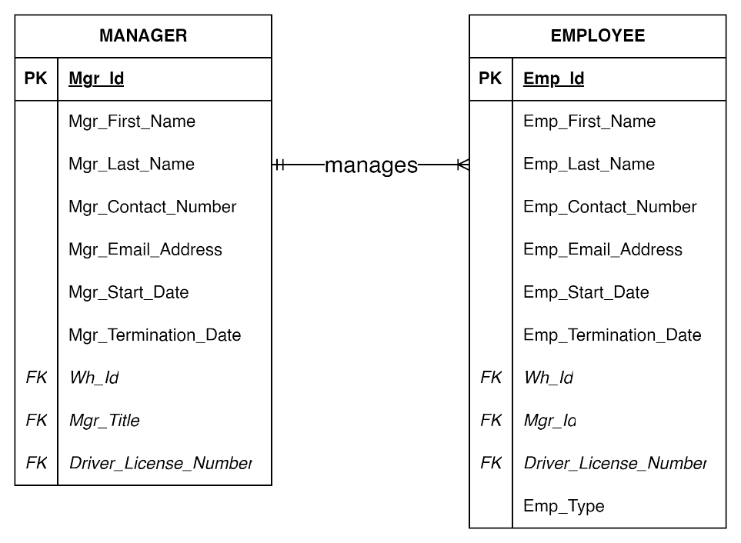

MANAGER TO EMPLOYEE: One-to-Many Mandatory (1:M)

EMPLOYEE to MANAGER: One-to-One Mandatory (1:1)

Each manager can manage one or more employees. (1, M)

Each employee is managed by only one manager. (1, 1)

1. 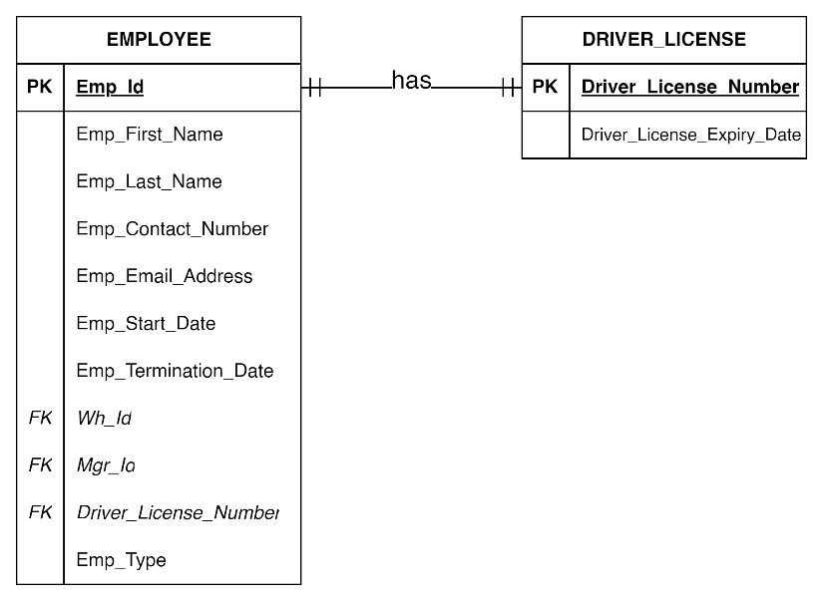

EMPLOYEE to DRIVER_LICENSE: One-to-One Mandatory (1:1)

DRIVER_LICENSE to EMPLOYEE: One-to-One Mandatory (1:1)

Each manager can only have on driver’s license. (1, 1)

Only one driver’s license can only be given to one manager. (1, 1)

1. 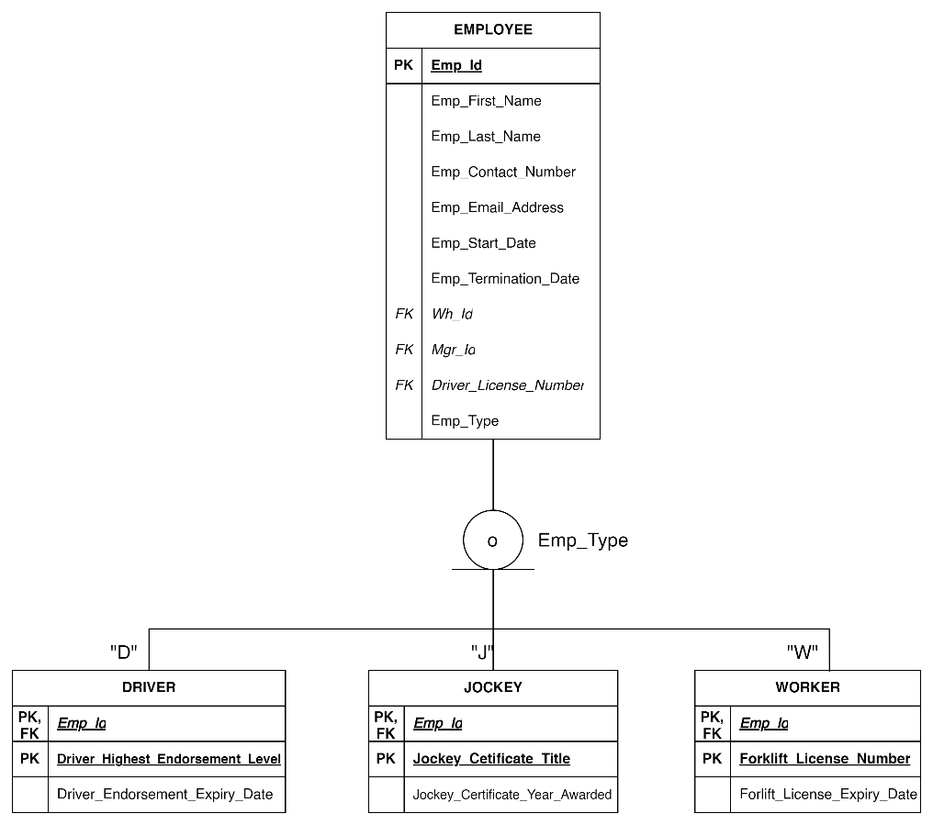

EMPLOYEE has overlapping subtypes and partial completeness to its subtypes DRIVER, JOCKEY and WORKER.

1. 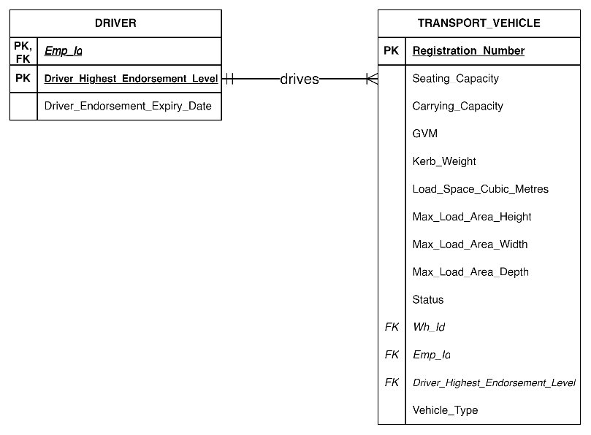

DRIVER to TRANSPORT_VEHICLE: One-to-Many Mandatory (1:M)

TRANSPORT_VEHICLE to DRIVER: One-to-One Mandatory (1:1)

Each driver can drive one or many transport vehicles. (1, M)

Each transport vehicle can only be driven by one driver. (1, 1)

1. 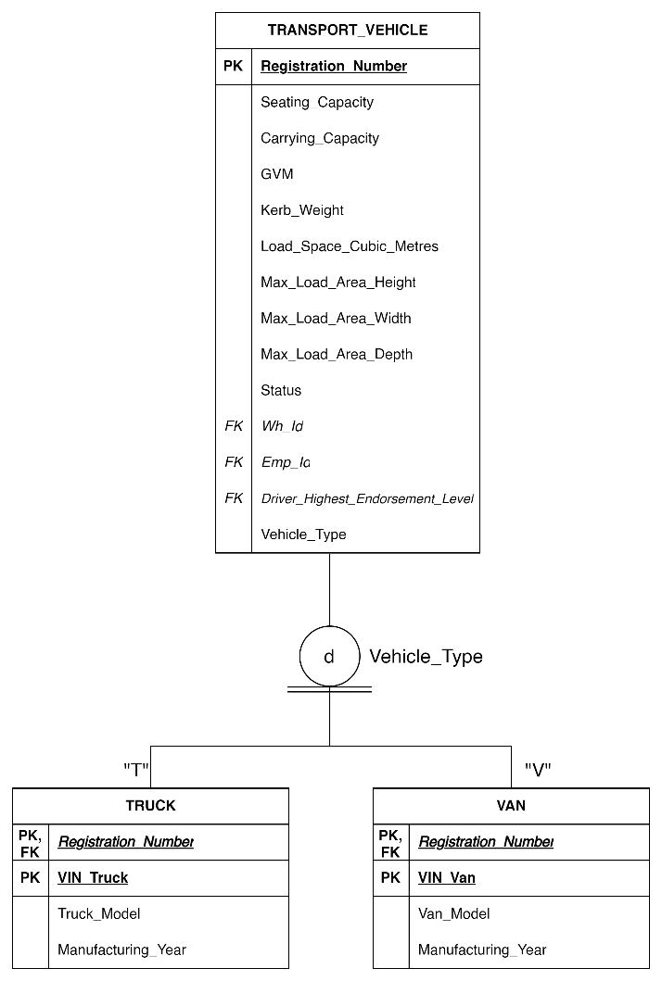

TRANSPORT_VEHICLE has disjoint subtypes and total completeness to its subtypes TRUCK and VAN.

1. 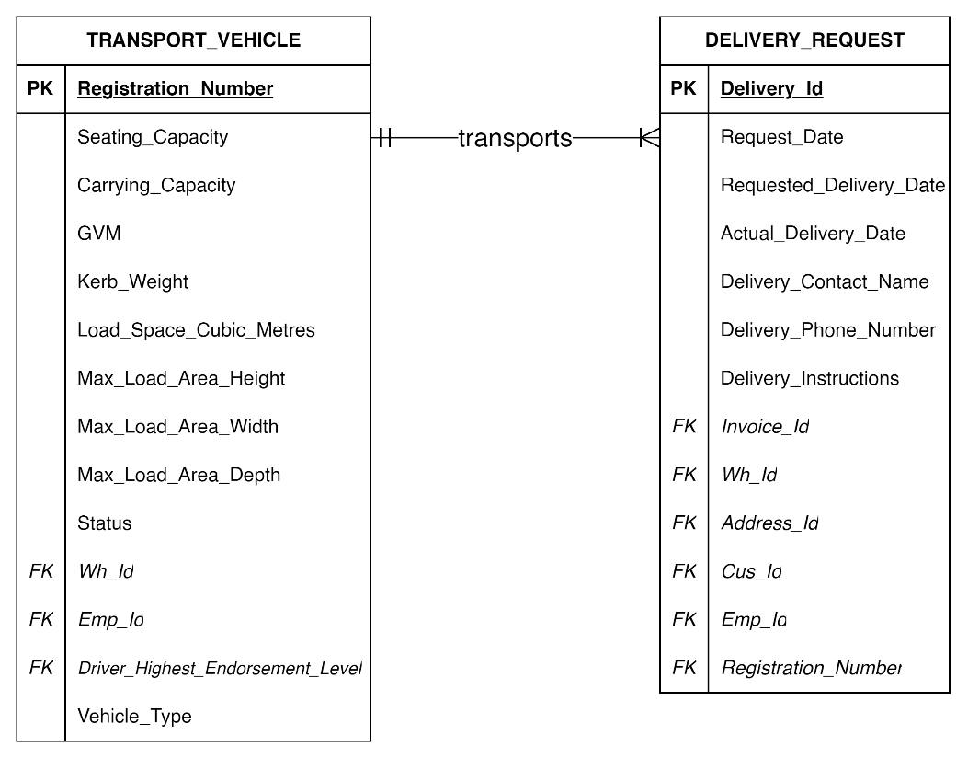

TRANSPORT_VEHICLE to DELIVERY_REQUEST: One-to-Many Mandatory (1:M)

DELIVERY_REQUEST to TRANSPORT_VEHICLE: One-to-One Mandatory (1:1)

Each transport vehicle can transport one or many delivery requests. (1, M)

Each delivery request can only be transported by one transport vehicle. (1, 1)

1. 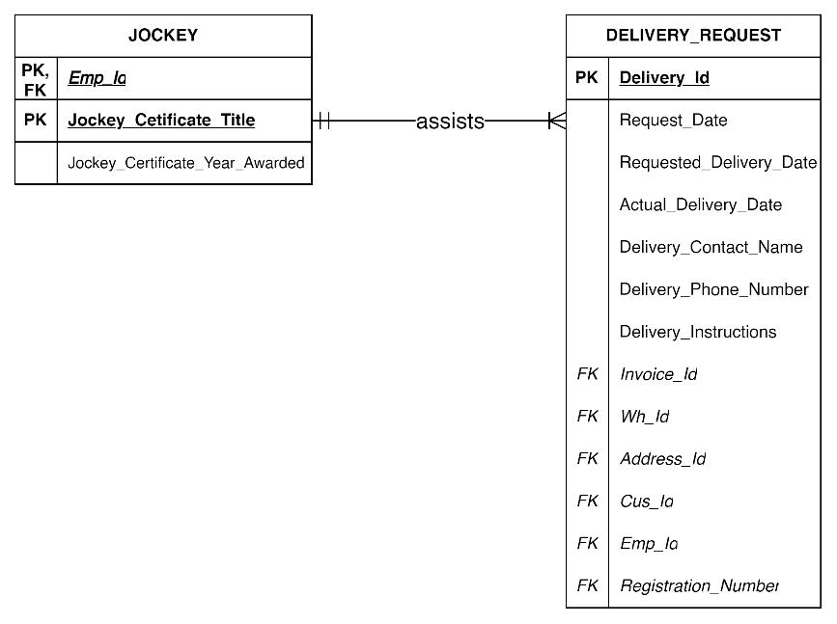

JOCKEY to DELIVERY_REQUEST: One-to-Many Mandatory (1:M)

DELIVERY_REQUEST to JOCKEY: One-to-One Mandatory (1:1)

Each jockey can assist one or many delivery requests. (1, M)

Each delivery request can only be assisted by one jockey. (1, 1)

1. 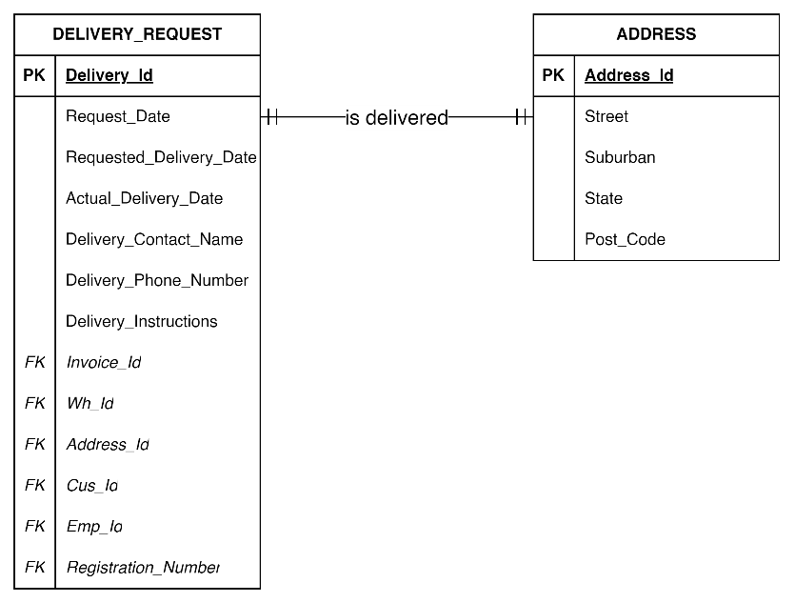

DELIVERY_REQUEST to ADDRESS: One-to-One Mandatory (1:1)

ADDRESS to DELIVERY_REQUEST: One-to-One Mandatory (1:1)

One delivery request must only be delivered in one address. (1, 1)

One address is only allocated for one delivery request. (1, 1)

1. 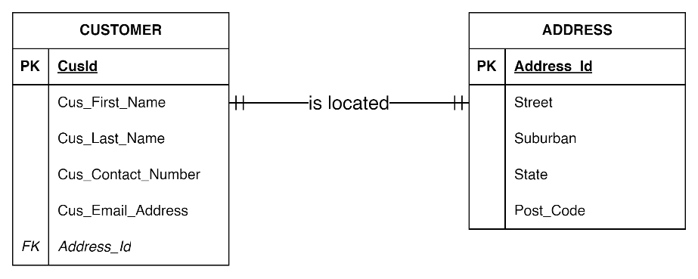

CUSTOMER to ADDRESS: One-to-One Mandatory (1:1)

ADDRESS to CUSTOMER: One-to-One Mandatory (1:1)

One customer must only be located in one address. (1, 1)

One address is only allocated for one customer. (1, 1)

1. 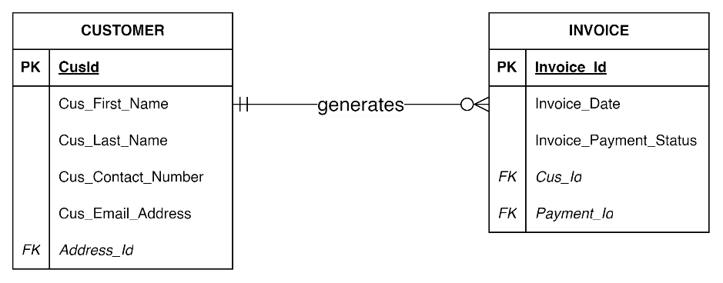

CUSTOMER to INVOICE: Zero-to-Many Optional (0:M)

INVOICE to CUSTOMER: One-to-One Mandatory (0:1)

Each customer can create one or many invoice. (1, M)

Every invoice can only be created by one customer. (1, 1)

1. 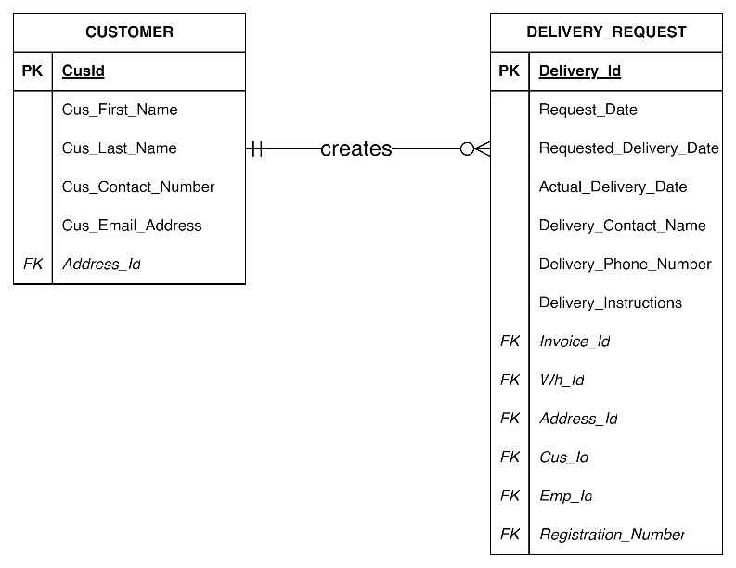

CUSTOMER to DELIVERY_REQUEST: Zero-to-Many Optional (0:M)

DELIVERY_REQUEST to CUSTOMER: One-to-One Mandatory (1:1)

Each customer can create zero or many delivery requests. (0, M)

Each delivery request can only be created by one customer. (1, 1)

1. 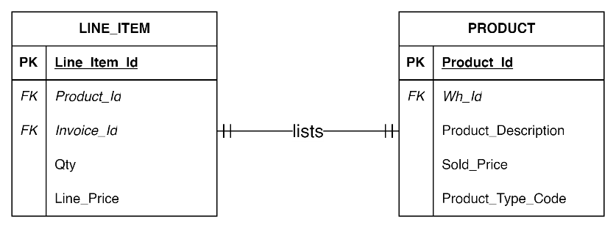

LINE_ITEM to PRODUCT: One-to-One Mandatory (1:1)

PRODUCT to LINE_ITEM: One-to-One Mandatory (1:1)

Each line item can only list one product. (1, 1)

Each product can only be listed in one line item. (1, 1)

1. 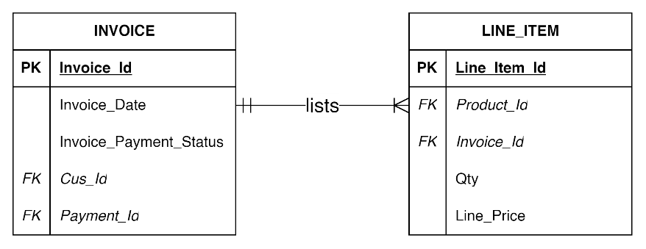

INVOICE to LINE_ITEM: One-to-Many Mandatory (1:M)

LINE_ITEM to INVOICE: One-to-One Mandatory (1:1)

Each invoice can list one or many purchase line. (1, M)

Each purchase line can be listed in one invoice. (1, 1)

1. 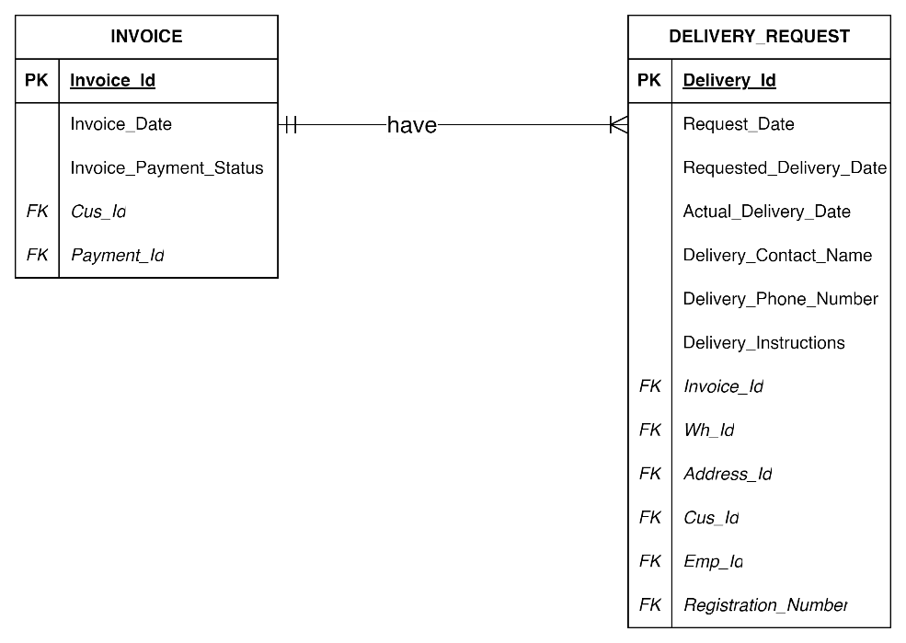

INVOICE to DELIVERY_REQUEST: One-to-Many Mandatory (1:M)

DELIVERY_REQUEST to INVOICE: One-to-One Mandatory (1:1)

Each invoice can have one or many delivery request. (1, M)

Each delivery request can only be listed in one invoice. (1, 1)

1. 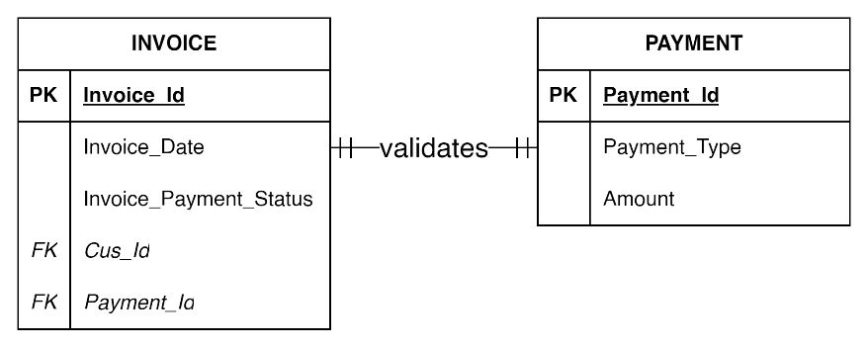

INVOICE to PAYMENT: One-to-One Mandatory (1:1)

PAYMENT to INVOICE: One-to-One Mandatory (1:1)

Each invoice can only be validated by one payment. (1, M)

Each payment can only validate one invoice. (1, 1)

# 6.0 ERD DIAGRAM

# 7.0 DATA DICTIONARY

Data Dictionary offers metadata about the data that explains each field's definition, data kinds, sample values, and other information (Herrick et al., 2014). It delivers data integrity by encouraging the adoption and usage of consistent data pieces, which make databases simpler to use and easier to comprehend for everyone working on a particular project.

|  |  |  |  |  |  |
| --- | --- | --- | --- | --- | --- |
| **Entity Name** | **Column Name** | **Data Type** | **Null Status** | **Key** | **Remark** |
| **ADDRESS** | Address_Id | VarChar(18) | Not Null | Primary Key |  |
|  | Street | VarChar(20) | Not Null |  |  |
|  | Suburban | VarChar(20) | Not Null |  |  |
|  | State | VarChar(3) | Not Null |  |  |
|  | Post_Code | Int | Not Null |  |  |
| **DRIVER_LICENSE** | Driver_License_Number | Int | Not Null | Primary Key |  |
|  | Driver_License_Expiry_Date | Date | Not Null |  |  |
| **MANAGER_ TITLE** | Mgr_Title | VarChar(6) | Not Null | Primary Key |  |
|  | Mgr_Highest_Qualification | VarChar(10) | Not Null |  |  |
|  | Mgr_Qualification_Date | Date | Not Null |  |  |
| **PAYMENT** | Payment_Id | VarChar(13) | Not Null | Primary Key |  |
|  | Payment_Type | VarChar(4) | Not Null |  |  |
|  | Amount | Numeric (24, 2) | Not Null |  |  |
| **WAREHOUSE** | Wh_Id | VarChar(7) | Not Null | Primary Key |  |
|  | Address_Id | VarChar(18) | Not Null |  | Foreign Key References ADDRESS (Address_Id) |
|  | Wh_Email_Address | VarChar(30) | Not Null |  |  |
|  | Wh_Phone_Number | Int | Not Null |  |  |
|  | Wh_Land_Area | Numeric (8,2) | Not Null |  |  |
|  | Wh_Loading_Bays | Int | Not Null |  |  |
|  | Wh_Access_Points | Int | Not Null |  |  |
| **MANAGER** | Mgr_Id | VarChar(8) | Not Null | Primary Key |  |
|  | Wh_Id | VarChar(7) | Not Null |  | Foreign Key References WAREHOUSE (Wh_Id) |
|  | Mgr_Title | VarChar(6) | Not Null |  | Foreign Key References MANAGER_TITLE (Mgr_Title) |
|  | Driver_License_Number | Int | Not Null |  | Foreign Key References DRIVER_LICENSE (Driver_License_Number) |
|  | Mgr_First_Name | VarChar(30) | Not Null |  |  |
|  | Mgr_Last_Name | VarChar(30) | Not Null |  |  |
|  | Mgr_Contact_Number | Int | Not Null |  |  |
|  | Mgr_Email_Address | VarChar(30) | Not Null |  |  |
|  | Mgr_Start_Date | Date | Not Null |  |  |
|  | Mgr_Termination_Date | Date | Not Null |  |  |
| **EMPLOYEE** | Emp_Id | VarChar(8) | Not Null | Primary Key |  |
|  | Wh_Id | VarChar(7) | Not Null |  | Foreign Key References WAREHOUSE (Wh_Id) |
|  | Mgr_Id | VarChar(8) | Not Null |  | Foreign Key References MANAGER (Mgr_Id) |
|  | Driver_License_Number | Int | Not Null |  | Foreign Key References DRIVER_LICENSE (Driver_License_Number) |
|  | Emp_First_Name | VarChar(30) | Not Null |  |  |
|  | Emp_Last_Name | VarChar(30) | Not Null |  |  |
|  | Emp_Contact_Number | Int | Not Null |  |  |
|  | Emp_Email_Address | VarChar(30) | Not Null |  |  |
|  | Emp_Start_Date | Date | Not Null |  |  |
|  | Emp_Termination_Date | Date | Not Null |  |  |
|  | Emp_Type | VarChar(30) | Not Null |  |  |
| **WORKER** | Emp_Id | VarChar(8) | Not Null | Primary Key | Foreign Key References EMPLOYEE(Emp_Id) |
|  | Worker_Forklift_License_Number | VarChar(9) | Not Null | Primary Key |  |
|  | Worker_Forklift_License_Expiry_Date | Date | Not Null |  |  |
| **DRIVER** | Emp_Id | VarChar(8) | Not Null | Primary Key | Foreign Key References EMPLOYEE(Emp_Id) |
|  | Driver_Highest_Endorsement_Level | VarChar(2) | Not Null | Primary Key |  |
|  | Driver_Endorsement_Expiry_Date | Date | Not Null |  |  |
| **JOCKEY** | Emp_Id | VarChar(8) | Not Null | Primary Key | Foreign Key References EMPLOYEE(Emp_Id) |
|  | Jockey_Certificate_Title | VarChar(8) | Not Null | Primary Key |  |
|  | Jockey_Certificate_Year_Awarded | Int | Not Null |  |  |
| **TRANSPORT_VEHICLE** | Registration_Number | VarChar(7) | Not Null | Primary Key |  |
|  | Wh_Id | VarChar(7) | Not Null |  | Foreign Key References WAREHOUSE (Wh_Id) |
|  | Emp_Id | VarChar(8) | Not Null |  | Foreign Key References DRIVER (Emp_Id) |
|  | Seating_Capacity | Int | Not Null |  |  |
|  | Carrying_Capacity | Int | Not Null |  |  |
|  | GVM | Int | Not Null |  |  |
|  | Kerb_Weight | Numeric (5,2) | Not Null |  |  |
|  | Load_Space_Cubic_Metres | Numeric (5,2) | Not Null |  |  |
|  | Max_Load_Area_Height | Numeric (5,2) | Not Null |  |  |
|  | Max_Load_Area_Width | Numeric (5,2) | Not Null |  |  |
|  | Max_Load_Area_Depth | Numeric (5,2) | Not Null |  |  |
|  | Vehicle_Status | VarChar(5) | Not Null |  |  |
|  | Vehicle_Type | VarChar(10) | Not Null |  |  |
| **VAN** | Registration_Number | VarChar(7) | Not Null | Primary Key | Foreign Key References TRANSPORT_VEHICLE (Registration_Number ) |
|  | VIN_Van | VarChar(18) | Not Null | Primary Key |  |
|  | Van_Model | VarChar(30) | Not Null |  |  |
|  | Manufacturing_Year | Date | Not Null |  |  |
| **TRUCK** | Registration_Number | VarChar(7) | Not Null | Primary Key | Foreign Key References TRANSPORT_VEHICLE (Registration_Number ) |
|  | VIN_Truck | VarChar(18) | Not Null |  |  |
|  | Van_Model | VarChar(30) | Not Null |  |  |
|  | Manufacturing_Year | Date | Not Null |  |  |
| **CUSTOMER** | Cus_Id | VarChar(13) | Not Null | Primary Key |  |
|  | Address_Id | VarChar(18) | Not Null |  | Foreign Key References ADDRESS (Address_Id) |
|  | Cus_First_Name | VarChar(30) | Not Null |  |  |
|  | Cus_Last_Name | VarChar(30) | Not Null |  |  |
|  | Cus_Contact_Number | VarChar(30) | Not Null |  |  |
|  | Cus_Email_Address | VarChar(30) | Not Null |  |  |
| **INVOICE** | Invoice_Id | VarChar(13) | Not Null | Primary Key |  |
|  | Cus_Id | VarChar(13) | Not Null |  | Foreign Key References CUSTOMER (Cus_Id) |
|  | Invoice_Date | Date |  |  |  |
|  | Invoice_Payment_Status | VarChar(30) |  |  |  |
|  | Payment_Id | VarChar(13) | Not Null |  | Foreign Key References PAYMENT (Payment_Id) |
| **PRODUCT** | Product_Id | VarChar(10) | Not Null | Primary Key |  |
|  | Wh_Id | VarChar(7) | Not Null |  | Foreign Key References WAREHOUSE (Wh_Id) |
|  | Product_Description | VarChar(50) | Not Null |  |  |
|  | Sold_Price | Numeric (5,2) | Not Null |  |  |
|  | Product_Type_Code | VarChar(30) | Not Null |  |  |
| **LINE_ITEM** | Line_Item_Id | VarChar(11) | Not Null | Primary Key |  |
|  | Product_Id | VarChar(10) | Not Null |  | Foreign Key References PRODUCT (Product_Id) |
|  | Invoice_Id | VarChar(13) | Not Null |  | Foreign Key References INVOICE (Invoice_Id) |
|  | Qty | Int | Not Null |  |  |
|  | Line_Price | Numeric (7,2) | Not Null |  |  |
| **DELIVERY_ REQUEST** | Delivery_Id | VarChar(12) | Not Null | Primary Key |  |
|  | Request_Date | Date | Not Null |  |  |
|  | Requested_Delivery_Date | Date | Not Null |  |  |
|  | Actual_Delivery_Date | Date | Not Null |  |  |
|  | Delivery_Contact_Name | VarChar(50) | Not Null |  |  |
|  | Delivery_Phone_Number | Int | Not Null |  |  |
|  | Delivery_Instructions | VarChar(200) | Not Null |  |  |
|  | Invoice_Id | VarChar(13) | Not Null |  | Foreign Key References INVOICE (Invoice_Id) |
|  | Wh_Id | VarChar(7) | Not Null |  | Foreign Key References WAREHOUSE (Address_Id) |
|  | Address_Id | VarChar(18) | Not Null |  | Foreign Key References ADDRESS (Address_Id) |
|  | Cus_Id | VarChar(13) |  |  | Foreign Key References CUSTOMER (Cus_Id) |
|  | Emp_Id | VarChar(8) | Not Null |  | Foreign Key References JOCKEY (Emp_Id) |
|  | Registration_Number | VarChar(7) | Not Null |  | Foreign Key References TRANSPORT_VEHCILE (Registration_Number) |

# 8.0 TABLES WITH DATA FOR EACH ATTRIBUTE

|  |  |  |  |  |
| --- | --- | --- | --- | --- |
| **ADDRESS** | | | | |
| Address_Id | Street | Suburban | State | Post_Code |
| 157_ON_HD_NSW_2158 | 157, Old Northern Road | Hills District | NSW | 2158 |
| 178_GR_C__QSL_4034 | 178 Gympie Road | Carseldine | QSL | 4034 |
| 026_IC_R__NSW_2112 | 26, Irvine Crescent | Ryde | NSW | 2112 |
| 004_BC_WH_VIC_3150 | 4, Bimbadeen Court | Wheelers Hill | VIC | 3150 |
| 086_SC_B__VIC_3480 | 86 Sullivan Court | Boolite | VIC | 3480 |
| 11A_HS_CP+NSW_2097 | 11A, Heather Street | Collaroy Plateau | NSW | 2097 |
| 041_WR_GC_QSL_4207 | 41, Woolshed Road | Gold Coast | QSL | 4207 |
| 012_FS_NM_VIC_3051 | 12, Fogarty Street | North Melbourne | VIC | 3051 |
| 018_KR_WP_NSW_2125 | 18, Keelendi Road | West Pennant Hills | NSW | 2125 |

|  |  |
| --- | --- |
| **DRIVER_LICENSE** | |
| Driver_License_Number | Driver_License_Expiry_Date |
| 358562600 | 2026/06/04 |
| 358562601 | 2025/03/10 |
| 358562602 | 2025/11/07 |
| 358562603 | 2026/04/22 |
| 358562604 | 2025/03/20 |
| 358562605 | 2025/09/09 |
| 358562606 | 2027/07/07 |
| 358562607 | 2026/10/02 |
| 358562608 | 2026/06/26 |
| 358562609 | 2025/03/10 |
| 358562610 | 2025/11/07 |
| 358562611 | 2026/04/22 |

|  |  |  |
| --- | --- | --- |
| **MANAGER_TITLE** | | |
| Mgr_Title | Mgr_Highest_Qualification | Mgr_Qualification_Date |
| MGRNSW | MASTERSNSW | 9/06/2022 |
| MGRVIC | MASTERSVIC | 22/07/2023 |
| MGRQSL | MASTERSQSL | 12/02/2023 |

|  |  |  |  |  |  |  |  |  |  |
| --- | --- | --- | --- | --- | --- | --- | --- | --- | --- |
| **MANAGER** | | | | | | | | | |
| Mgr_Id | Wh_Id | Mgr_Title | Driver_License_Number | Mgr_First_Name | Mgr_Last_Name | Mgr_Contact_Number | Mgr_Email_Address | Mgr_Start_Date | Mgr_Termination_Date |
| TFY00350 | TOYNSW1 | MGRNSW | 358562600 | Caleigh | Stevie | 480527702 | [c.stevie@tfy.com.au](mailto:c.stevie@tfy.com.au) | 16/10/2018 | 16/10/2023 |
| TFY00351 | TOYVIC1 | MGRVIC | 358562601 | Chase | Driscoll | 480527703 | [c.driscoll@tfy.com.au](mailto:c.driscoll@tfy.com.au) | 1/04/2023 | 1/04/2028 |
| TFY00352 | TOYQSL1 | MGRQSL | 358562602 | Gabe | Adrian | 480527704 | [g.adrian@tfy.com.au](mailto:g.adrian@tfy.com.au) | 30/06/2021 | 30/06/2026 |

|  |  |  |  |  |  |  |
| --- | --- | --- | --- | --- | --- | --- |
| **WAREHOUSE** | | | | | | |
| Wh_Id | Address_Id | Wh_Email_Address | Wh_Phone_Number | Wh_LandArea | Wh_Loading_Bays | Wh_Access_Points |
| TOYNSW1 | 157_ON_HD_NSW_2158 | [toynsw1@tfy.com.au](mailto:toynsw1@tfy.com.au) | 552796245 | 2400 | 5 | 10 |
| TOYVIC1 | 004_BC_WH_VIC_3150 | [toyvic1@tfy.com.au](mailto:toyvic1@tfy.com.au) | 552796246 | 2450 | 6 | 12 |
| TOYQSL1 | 178_GR_C__QSL_4034 | [toyqsl1@tfy.com.au](mailto:toyqsl1@tfy.com.au) | 0552 796 247 | 2500 | 5 | 14 |

|  |  |  |
| --- | --- | --- |
| **PAYMENT** | | |
| Payment_Id | Payment_Type | Amount |
| PAYTFY1000023 | Card | 95.4 |
| PAYTFY1000024 | Card | 96.5 |
| PAYTFY1000025 | Card | 148.5 |

|  |  |  |  |  |  |  |  |  |  |  |
| --- | --- | --- | --- | --- | --- | --- | --- | --- | --- | --- |
| **EMPLOYEE** | | | | | | | | | | |
| Emp_Id | Wh_Id | Mgr_Id | Driver_License_Number | Emp_First_Name | Emp_Last_Name | Emp_Contact_Number | Emp_Email_Address | Emp_Start_Date | Emp_Termination_Date | Emp_Type |
| TFY01781 | TOYNSW1 | TFY00350 | 358562603 | Barnaby | Miles | 480527705 | [b.miles@tfy.com.au](mailto:b.miles@tfy.com.au) | 2019-05-12 | 2019-05-12 | Worker |
| TFY01782 | TOYNSW1 | TFY00350 | 358562604 | Evan | Tolly | 480527706 | [e.tolly@tfy.com.au](mailto:e.tolly@tfy.com.au) | 2021-10-09 | 2026-10-09 | Jockey |
| TFY01783 | TOYNSW1 | TFY00350 | 358562605 | Promise | Meredith | 480527707 | [p.meredith@tfy.com.au](mailto:p.meredith@tfy.com.au) | 2024-11-16 | 2029-11-16 | Driver |
| TFY01784 | TOYVIC1 | TFY00351 | 358562606 | Rodger | Valentine | 480527708 | [r.valentine@tfy.com.au](mailto:r.valentine@tfy.com.au) | 2018-11-04 | 2023-11-04 | Worker |
| TFY01785 | TOYVIC1 | TFY00351 | 358562607 | Harland | Deacon | 480527709 | [h.deacon@tfy.com.au](mailto:h.deacon@tfy.com.au) | 2019-02-11 | 2024-02-11 | Jockey |
| TFY01786 | TOYVIC1 | TFY00351 | 358562608 | Karter | Faron | 480527710 | [k.faron@tfy.com.au](mailto:k.faron@tfy.com.au) | 2020-11-28 | 2025-11-28 | Driver |
| TFY01787 | TOYQSL1 | TFY00352 | 358562609 | Sinclair | Ward | 480527711 | [s.ward@tfy.com.au](mailto:s.ward@tfy.com.au) | 2022-03-27 | 2027-03-27 | Worker |
| TFY01788 | TOYQSL1 | TFY00352 | 358562610 | Denny | Travers | 480527712 | [d.travers@tfy.com.au](mailto:d.travers@tfy.com.au) | 2023-12-21 | 2028-12-21 | Jockey |
| TFY01789 | TOYQSL1 | TFY00352 | 358562611 | Vyvyan | Jackie | 480527713 | [v.jackie@tfy.com.au](mailto:v.jackie@tfy.com.au) | 2023-12-21 | 2028-01-28 | Driver |

|  |  |  |
| --- | --- | --- |
| **WORKER** | | |
| Emp_Id | Worker_Forklift_License_Number | Worker_Forklift_License_Expiry_Date |
| TFY01781 | HRW000100 | 2027-09-30 |
| TFY01784 | HRW000101 | 2025-10-15 |
| TFY01787 | HRW000102 | 2026-03-31 |

|  |  |  |
| --- | --- | --- |
| **DRIVER** | | |
| Emp_Id | Driver_Highest_Endorsement_Level | Driver_Endorsement_Expiry_Date |
| TFY01783 | T1 | 30/09/2027 |
| TFY01786 | T1 | 15/10/2025 |
| TFY01789 | T1 | 31/03/2026 |

|  |  |  |  |  |  |  |  |  |  |  |  |  |  |  |
| --- | --- | --- | --- | --- | --- | --- | --- | --- | --- | --- | --- | --- | --- | --- |
| **JOCKEY** | | | | | | | | | | | | | | |
| Emp_Id | | | | | | Jockey_Certificate_Title | | | | | Jockey_Certificate_Year_Awarded | | | |
| TFY01782 | | | | | | RGR40218 | | | | | 2020 | | | |
| TFY01785 | | | | | | RGR40219 | | | | | 2021 | | | |
| TFY01788 | | | | | | RGR40220 | | | | | 2022 | | | |
| **TRANSPORT_VEHICLE** | | | | | | | | | | | | | | | |
| Registration_Number | | Wh_Id | Emp_Id | Seating_Capacity | Carrying_Capacity | GVM | | Kerb_Weight | Load_Space_Cubic_Metres | Max_Load_Area_Height | Max_Load_Area_Width | | Max_Load_Area_Depth | Vehicle_Status | Vehicle_Type |
| TEBY50Y | | TOYNSW1 | TFY01783 | 2 | 907 | 3500 | | 2593 | 40 | 2 | 2.4 | | 4 | Out | Truck |
| VEBY49Z | | TOYVIC1 | TFY01786 | 2 | 600 | 3000 | | 2400 | 15 | 1.3 | 1.5 | | 2 | In | Van |
| TEBY48A | | TOYQSL1 | TFY01789 | 2 | 907 | 3500 | | 2593 | 40 | 2 | 2.4 | | 4 | Out | Truck |
| VEBY47B | | TOYNSW1 | TFY01783 | 2 | 600 | 3000 | | 2400 | 15 | 1.3 | 1.5 | | 2 | In | Van |
| TEBY46C | | TOYVIC1 | TFY01786 | 2 | 907 | 3500 | | 2593 | 40 | 2 | 2.4 | | 4 | Out | Truck |
| VEBY45D | | TOYQSL1 | TFY01789 | 2 | 600 | 3000 | | 2400 | 15 | 1.3 | 1.5 | | 2 | In | Van |

|  |  |  |  |
| --- | --- | --- | --- |
| **VAN** | | | |
| Registration_Number | VIN_Van | Van_Model | Manufacturing_Year |
| VEBY49Z | VANLCPCBVIC1100237 | FORDTRANSIT2022-003 | 2022 |
| VEBY47B | VANLCPCBNSW1100238 | FORDTRANSIT2022-004 | 2022 |
| VEBY45D | VANLCPCBQSL1100239 | FORDTRANSIT2022-005 | 2022 |

|  |  |  |  |
| --- | --- | --- | --- |
| **TRUCK** | | | |
| Registration_Number | VIN_Truck | Truck_Model | Manufacturing_Year |
| TEBY46C | TRULCPCBVIC1104575 | ISUZUNSERIES2022-004 | 2022 |
| TEBY50Y | TRULCPCBNSW1104576 | ISUZUNSERIES2022-005 | 2022 |
| TEBY48C | TRULCPCBQSL1104577 | ISUZUNSERIES2022-006 | 2022 |

|  |  |  |  |  |  |
| --- | --- | --- | --- | --- | --- |
| **CUSTOMER** | | | | | |
| Cus_Id | Address_Id | Cus_First_Name | Cus_Last_Name | Cus_Contact_Number | Cus_Email_Address |
| CUS0123901457 | 026_IC_R__NSW_2112 | Lauren | Geena | 0226 782 583 | [l.geena@customer.com.au](mailto:l.geena@customer.com.au) |
| CUS0123901458 | 11A_HS_CP_NSW_2097 | Em | Scarlett | 0226 782 584 | [e.scarlett@customer.com.au](mailto:e.scarlett@customer.com.au) |
| CUS0123901459 | 012_FS_NM_VIC_3051 | Ophelia | Isabel | 0226 782 585 | [o.isabel@customer.com.au](mailto:o.isabel@customer.com.au) |

|  |  |  |  |  |
| --- | --- | --- | --- | --- |
| **INVOICE** | | | | |
| Invoice_Id | Cus_Id | Invoice_Date | Invoice_Payment_Status | Payment_Id |
| INV123014921A | CUS0123901457 | 2023-09-06 | Payed | PAYTFY1000023 |
| INV123014922B | CUS0123901458 | 2023-09-07 | Payed | PAYTFY1000024 |
| INV123014923C | CUS0123901459 | 2023-09-08 | Payed | PAYTFY1000025 |

|  |  |  |  |  |
| --- | --- | --- | --- | --- |
| **PRODUCT** | | | | |
| Product_Id | Wh_Id | Product_Description | Sold_Price | Product_Type_Code |
| PRO230957A | TOYNSW1 | Big Bear | 23.85 | 1234567890 |
| PRO230958B | TOYVIC1 | Red Bike | 48.25 | 1234567891 |
| PRO230959C | TOYNSW1 | Blue Bike | 49.5 | 1234567892 |

|  |  |  |  |  |
| --- | --- | --- | --- | --- |
| **LINE_ITEM** | | | | |
| Line_Item_Id | Product_Id | Invoice_Id | Qty | Line_Price |
| LINSW000001 | PRO230957A | INV123014921A | 4 | 95.4 |
| LINSW000002 | PRO230959C | INV123014922B | 2 | 96.5 |
| LIVIC000001 | PRO230958B | INV123014922B | 3 | 148.5 |

|  |  |  |  |  |  |  |  |  |  |  |  |  |
| --- | --- | --- | --- | --- | --- | --- | --- | --- | --- | --- | --- | --- |
| **DELIVERY_REQUEST** | | | | | | | | | | | | |
| Delivery_Id | Request_Date | Requested_Delivery_Date | Actual_Delivery_Date | Delivery_Contact_Name | Delivery_Phone_Number | Delivery_Instructions | Invoice_Id | Wh_Id | Address_Id | Cus_Id | Emp_Id | Registration_Number |
| DLNSW0104579 | 2023-09-06 | 2023-09-13 | 2023-09-14 | Lauren Geena | 0226 782 583 | Put beside the mail box. | INV123014921A | TOYNSW1 | 026_IC_R__NSW_2112 | CUS0123901457 | TFY01782 | TEBY50Y |
| DLNSW0104580 | 2023-09-07 | 2023-09-14 | 2023-09-13 | Maybelle Zeb | 0226 783 457 | Drop by the front door | INV123014922B | TOYNSW1 | 018_KR_WP_NSW_2125 | CUS0123901458 | TFY01782 | TEBY50Y |
| DLVIC0104590 | 2023-09-08 | 2023-09-15 | 2023-09-15 | Opelia Isabel | 0226 782 585 | Drop by the front door | INV123014923B | TOYVIC1 | 012_FS_NM_VIC_3051 | CUS0123901458 | TFY01785 | TEBY46C |

# 9.0 DDL STATEMENTS

The structure of items in a database may be created and modified using specified commands and a particular syntax utilizing the data definition language (DDL). They consist of tables, sequences, locations, aliases, schemas, and indexes (Juba et al, 2015).

/*---- Creating Database ----*/

CREATE DATABASE ICT702_12301175_Individual_Assignment;

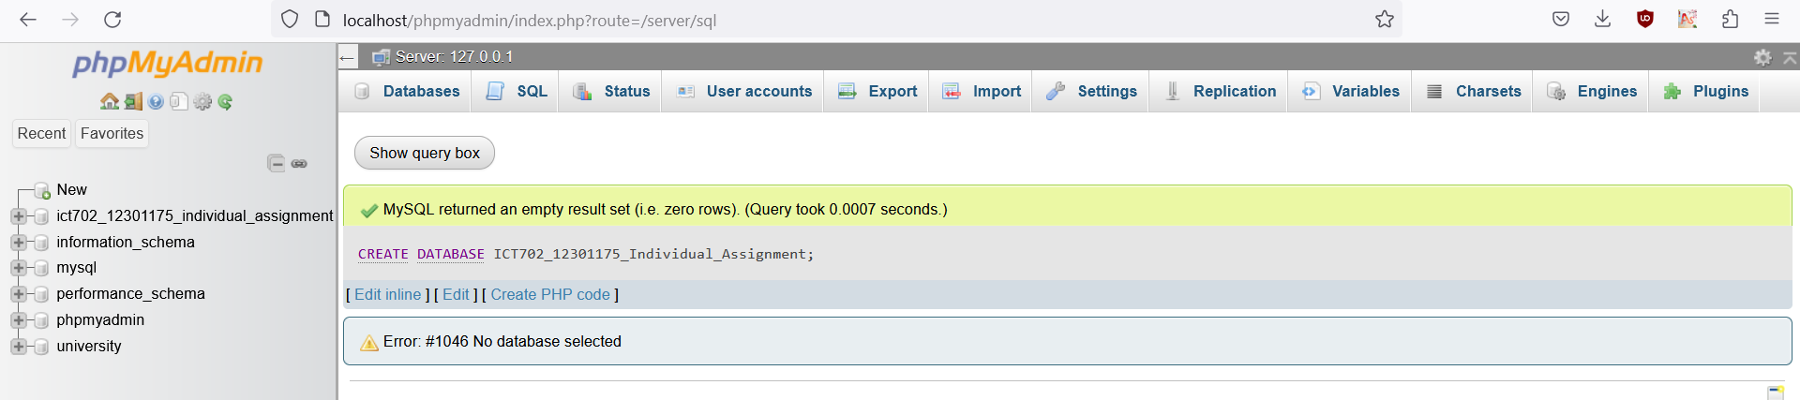

/*---- Table structure for table ‘ADDRESS’ ---- */

CREATE TABLE ADDRESS

(

Address_Id VARCHAR(18) NOT NULL PRIMARY KEY,

Street VARCHAR(50) NOT NULL,

Suburban VARCHAR(50) NOT NULL,

State VARCHAR(3) NOT NULL,

Post_Code INT NOT NULL

);

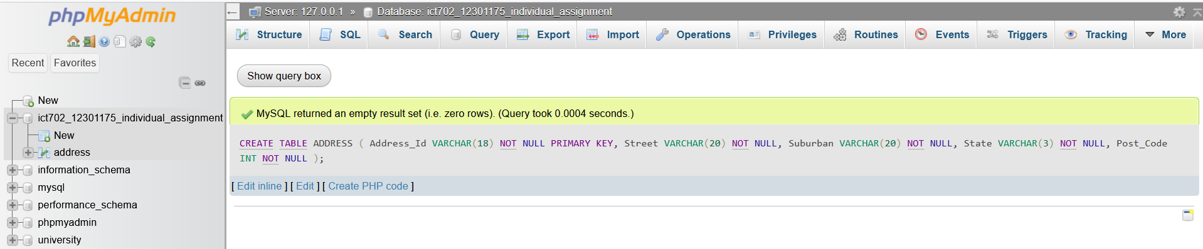

/*---- Table structure for table ‘DRIVER_LICENSE’ ---- */

CREATE TABLE DRIVER_LICENSE

(

Driver_License_Number INT NOT NULL PRIMARY KEY,

Driver_License_Expiry_Date DATE NOT NULL

);

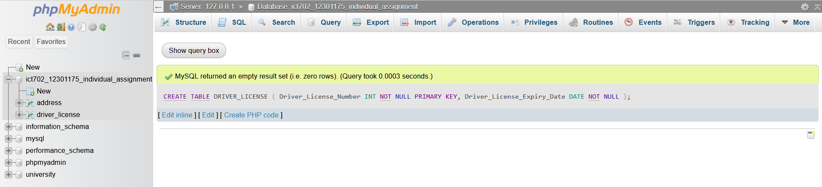

/*---- Table structure for table ‘MANAGER_TITLE’ ---- */

CREATE TABLE MANAGER_TITLE

(

Mgr_Title VARCHAR(6) NOT NULL PRIMARY KEY,

Mgr_Highest_Qualification VARCHAR(10) NOT NULL,

Mgr_Qualification_Date DATE NOT NULL

);

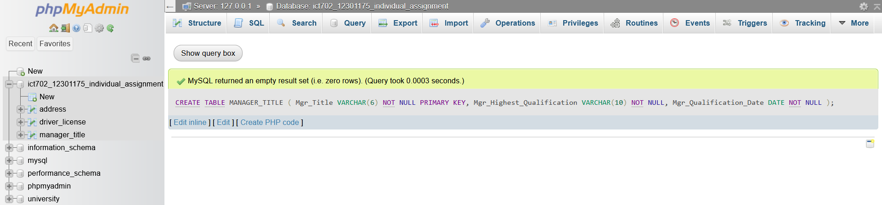

/*---- Table structure for table ‘PAYMENT’ ---- */

CREATE TABLE PAYMENT

(

Payment_Id VARCHAR(13) NOT NULL PRIMARY KEY,

Payment_Type VARCHAR(4) NOT NULL,

Amount NUMERIC(24, 2) NOT NULL

);

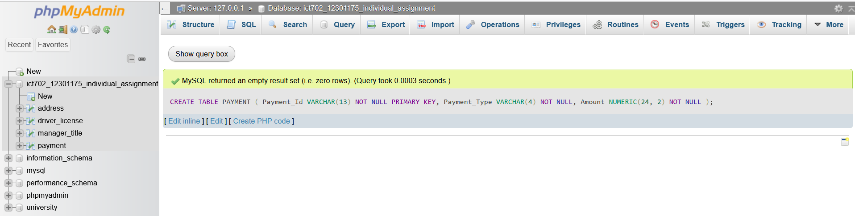

/*---- Table structure for table ‘WAREHOUSE’ ---- */

CREATE TABLE WAREHOUSE

(

Wh_Id VARCHAR(7) NOT NULL PRIMARY KEY,

Address_Id VARCHAR(18) NOT NULL,

Wh_Email_Address VARCHAR(30) NOT NULL,

Wh_Phone_Number INT NOT NULL,

Wh_Land_Area NUMERIC(8,2) NOT NULL,

Wh_Loading_Bays INT NOT NULL,

Wh_Access_Points INT NOT NULL,

FOREIGN KEY(Address_Id) REFERENCES ADDRESS(Address_Id)

);

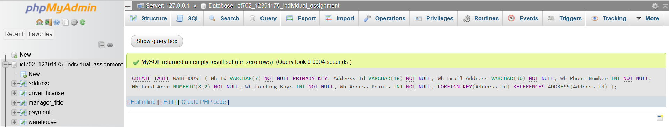

/*---- Table structure for table ‘MANAGER’ ---- */

CREATE TABLE MANAGER

(

Mgr_Id VARCHAR(8) NOT NULL PRIMARY KEY,

Wh_Id VARCHAR(7) NOT NULL,

Mgr_Title VARCHAR(6) NOT NULL,

Driver_License_Number INT NOT NULL,

Mgr_First_Name VARCHAR(30) NOT NULL,

Mgr_Last_Name VARCHAR(30) NOT NULL,

Mgr_Contact_Number INT NOT NULL,

Mgr_Email_Address VARCHAR(30) NOT NULL,

Mgr_Start_Date DATE NOT NULL,

Mgr_Termination_Date DATE NOT NULL,

FOREIGN KEY(Wh_Id) REFERENCES WAREHOUSE(Wh_Id),

FOREIGN KEY(Mgr_Title) REFERENCES MANAGER_TITLE(Mgr_Title),

FOREIGN KEY(Driver_License_Number) REFERENCES DRIVER_LICENSE(Driver_License_Number)

);

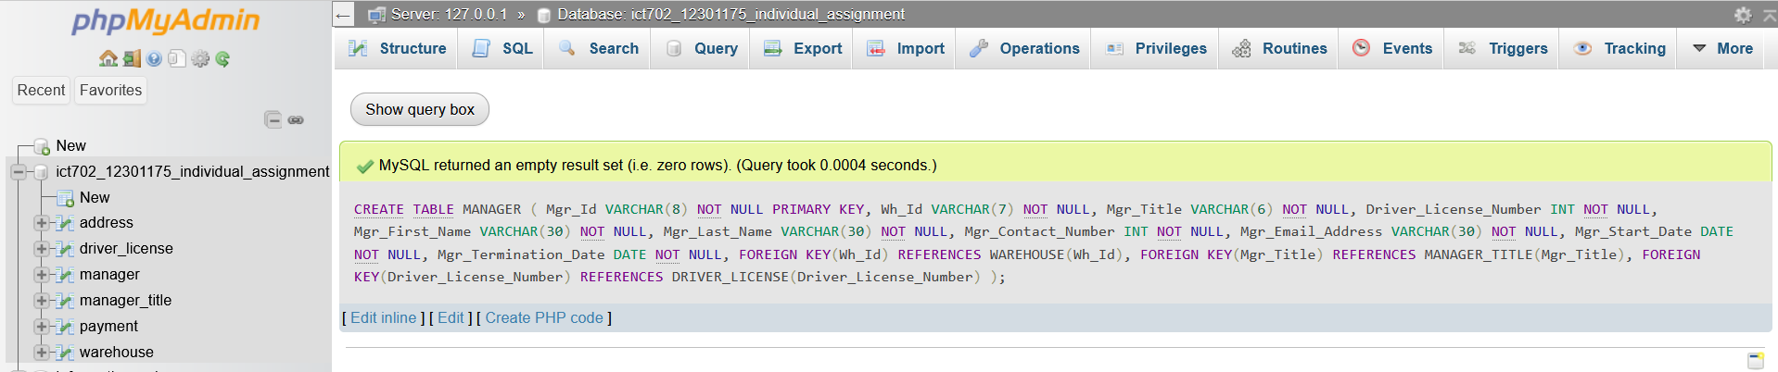

/*---- Table structure for table ‘EMPLOYEE’ ---- */

CREATE TABLE EMPLOYEE

(

Emp_Id VARCHAR(8) NOT NULL PRIMARY KEY,

Wh_Id VARCHAR(7) NOT NULL,

Mgr_Id VARCHAR(8) NOT NULL,

Driver_License_Number INT NOT NULL,

Emp_First_Name VARCHAR(30) NOT NULL,

Emp_Last_Name VARCHAR(30) NOT NULL,

Emp_Contact_Number INT NOT NULL,

Emp_Email_Address VARCHAR(30) NOT NULL,

Emp_Start_Date DATE NOT NULL,

Emp_Termination_Date DATE NOT NULL,

Emp_Type VARCHAR(30) NOT NULL,

FOREIGN KEY(Wh_Id) REFERENCES WAREHOUSE(Wh_Id),

FOREIGN KEY(Mgr_Id) REFERENCES MANAGER(Mgr_Id),

FOREIGN KEY(Driver_License_Number) REFERENCES DRIVER_LICENSE(Driver_License_Number)

);

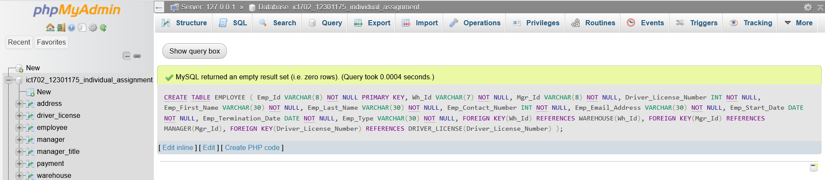

/*---- Table structure for table ‘WORKER’ ---- */

CREATE TABLE WORKER

(

Emp_Id VARCHAR(8) NOT NULL,

Worker_Forklift_License_Number VARCHAR(9) NOT NULL,

Worker_Forklift_License_Expiry_Date DATE NOT NULL,

PRIMARY KEY(Emp_Id, Worker_Forklift_License_Number),

FOREIGN KEY(Emp_Id) REFERENCES EMPLOYEE(Emp_Id)

);

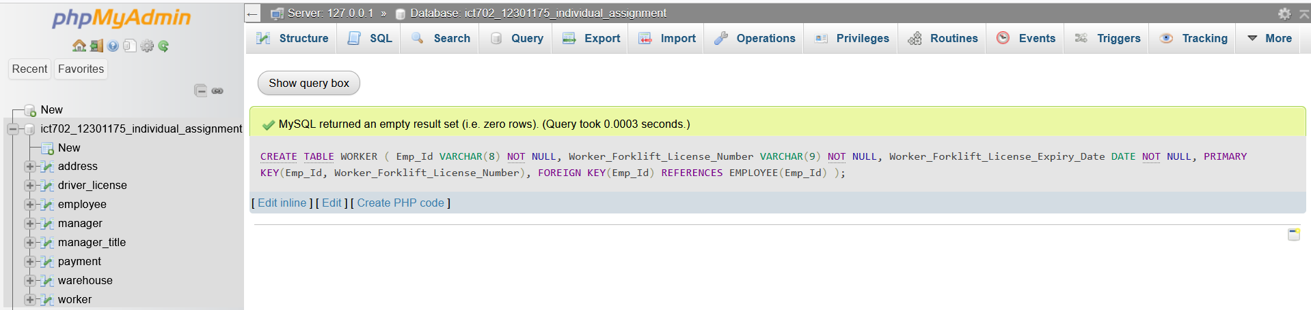

/*---- Table structure for table ‘DRIVER’ ---- */

CREATE TABLE DRIVER

(

Emp_Id VARCHAR(8) NOT NULL,

Driver_Highest_Endorsement_Level VARCHAR(2) NOT NULL,

Driver_Endorsement_Expiry_Date DATE NOT NULL,

PRIMARY KEY(Emp_Id, Driver_Highest_Endorsement_Level),

FOREIGN KEY(Emp_Id) REFERENCES EMPLOYEE(Emp_Id)

);

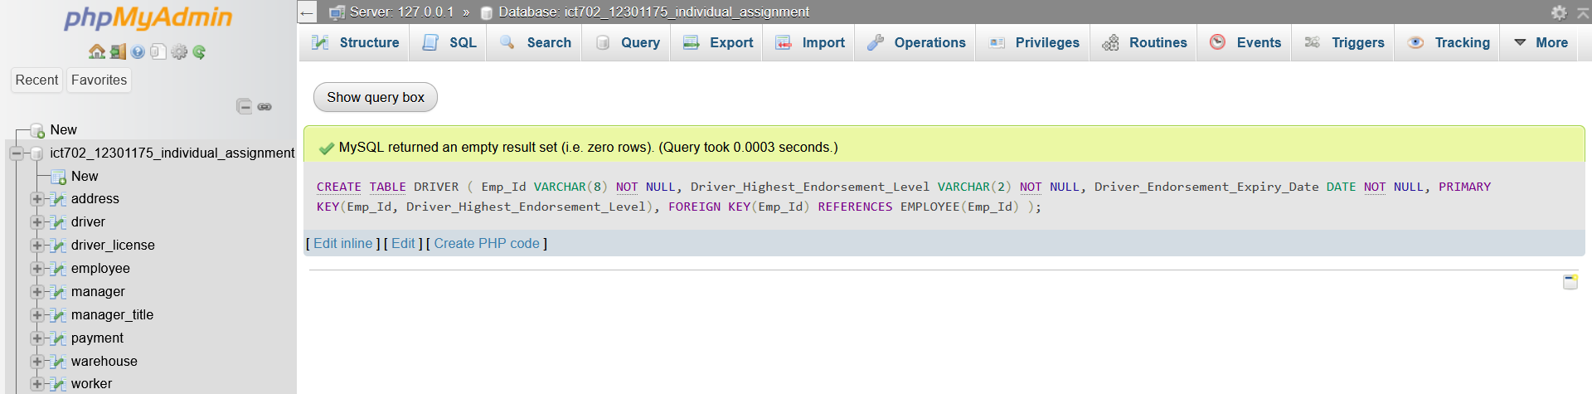

/*---- Table structure for table ‘JOCKEY’ ---- */

CREATE TABLE JOCKEY

(

Emp_Id VARCHAR(8) NOT NULL,

Jockey_Certificate_Title VARCHAR(8) NOT NULL,

Jockey_Certificate_Year_Awarded INT NOT NULL,

PRIMARY KEY(Emp_Id, Jockey_Certificate_Title),

FOREIGN KEY(Emp_Id) REFERENCES EMPLOYEE(Emp_Id)

);

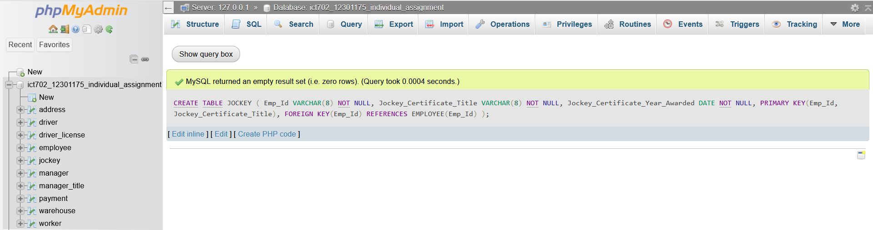

/*---- Table structure for table ‘TRANSPORT_VEHICLE’ ---- */

CREATE TABLE TRANSPORT_VEHICLE

(

Registration_Number VARCHAR(7) NOT NULL PRIMARY KEY,

Wh_Id VARCHAR(7) NOT NULL,

Emp_Id VARCHAR(8) NOT NULL,

Seating_Capacity INT NOT NULL,

Carrying_Capacity INT NOT NULL,

GVM INT NOT NULL,

Kerb_Weight INT NOT NULL,

Load_Space_Cubic_Metres NUMERIC(5,2) NOT NULL,

Max_Load_Area_Height NUMERIC(5,2) NOT NULL,

Max_Load_Area_Width NUMERIC(5,2) NOT NULL,

Max_Load_Area_Depth NUMERIC(5,2) NOT NULL,

Vehicle_Status VARCHAR(5) NOT NULL,

Vehicle_Type VARCHAR(10) NOT NULL,

FOREIGN KEY(Wh_Id) REFERENCES WAREHOUSE(Wh_Id),

FOREIGN KEY(Emp_Id) REFERENCES DRIVER(Emp_Id)

);

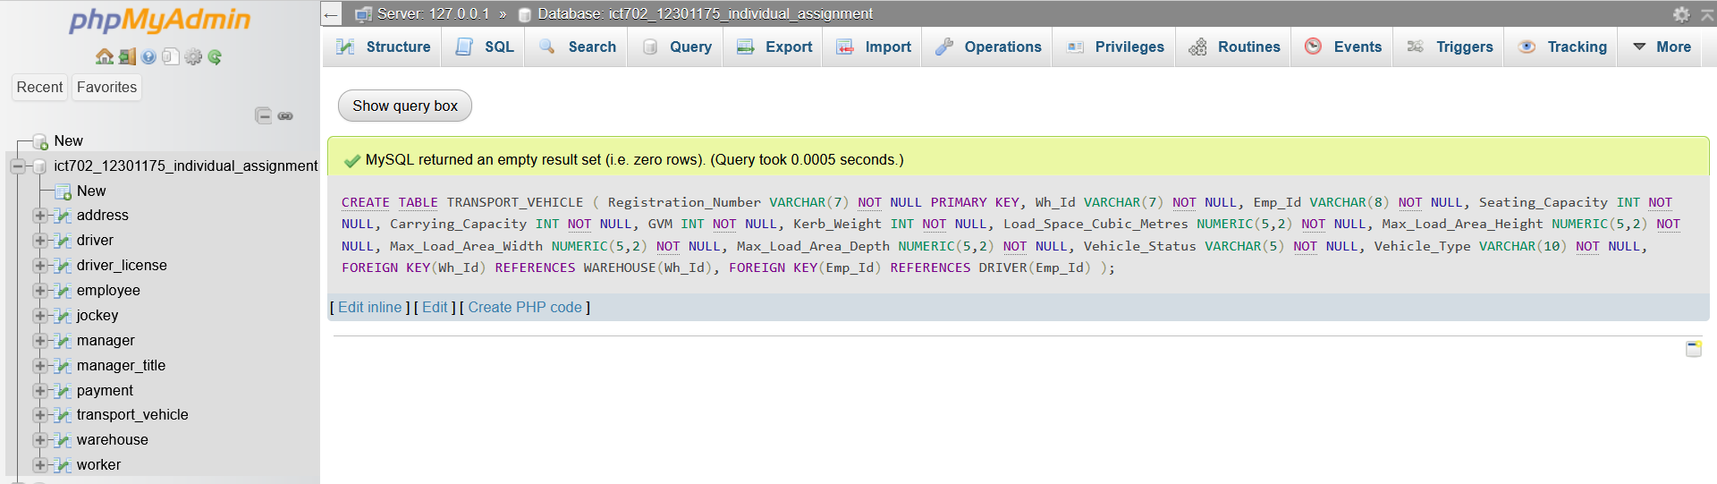

/*---- Table structure for table ‘VAN’ ---- */

CREATE TABLE VAN

(

Registration_Number VARCHAR(7) NOT NULL,

VIN_Van VARCHAR(18) NOT NULL,

Van_Model VARCHAR(20) NOT NULL,

Manufacturing_Year INT NOT NULL,

PRIMARY KEY(Registration_Number, VIN_Van),

FOREIGN KEY(Registration_Number) REFERENCES TRANSPORT_VEHICLE(Registration_Number)

);

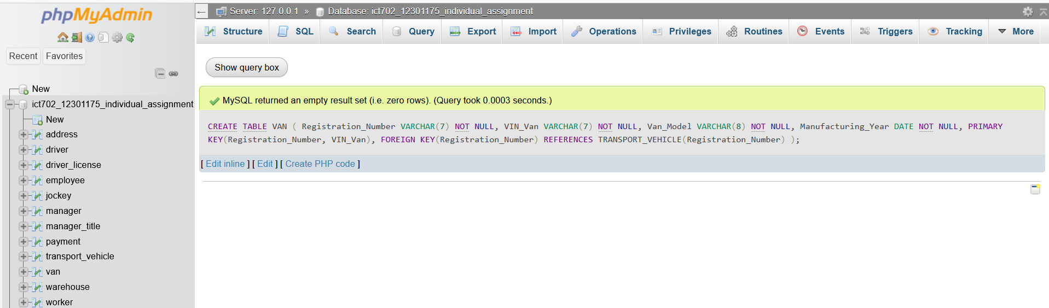

/*---- Table structure for table ‘TRUCK’---- */

CREATE TABLE TRUCK

(

Registration_Number VARCHAR(7) NOT NULL,

VIN_Truck VARCHAR(18) NOT NULL,

Truck_Model VARCHAR(20) NOT NULL,

Manufacturing_Year int NOT NULL,

PRIMARY KEY(Registration_Number, VIN_Truck),

FOREIGN KEY(Registration_Number) REFERENCES TRANSPORT_VEHICLE(Registration_Number)

);

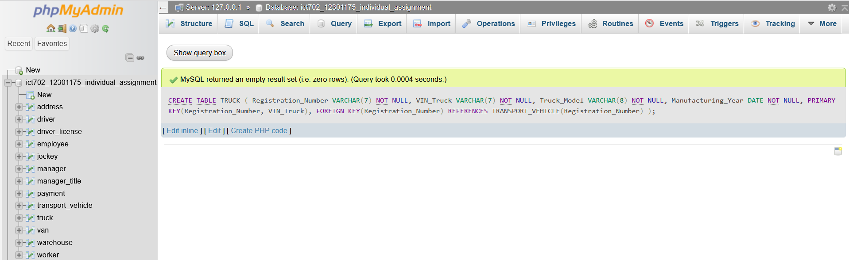

/*---- Table structure for table ‘CUSTOMER’---- */

CREATE TABLE CUSTOMER

(

Cus_Id VARCHAR(13) NOT NULL PRIMARY KEY,

Address_Id VARCHAR(18) NOT NULL,

Cus_First_Name VARCHAR(30) NOT NULL,

Cus_Last_Name VARCHAR(30) NOT NULL,

Cus_Contact_Number INT NOT NULL,

Cus_Email_Address VARCHAR(30) NOT NULL,

FOREIGN KEY(Address_Id) REFERENCES ADDRESS(Address_Id)

);

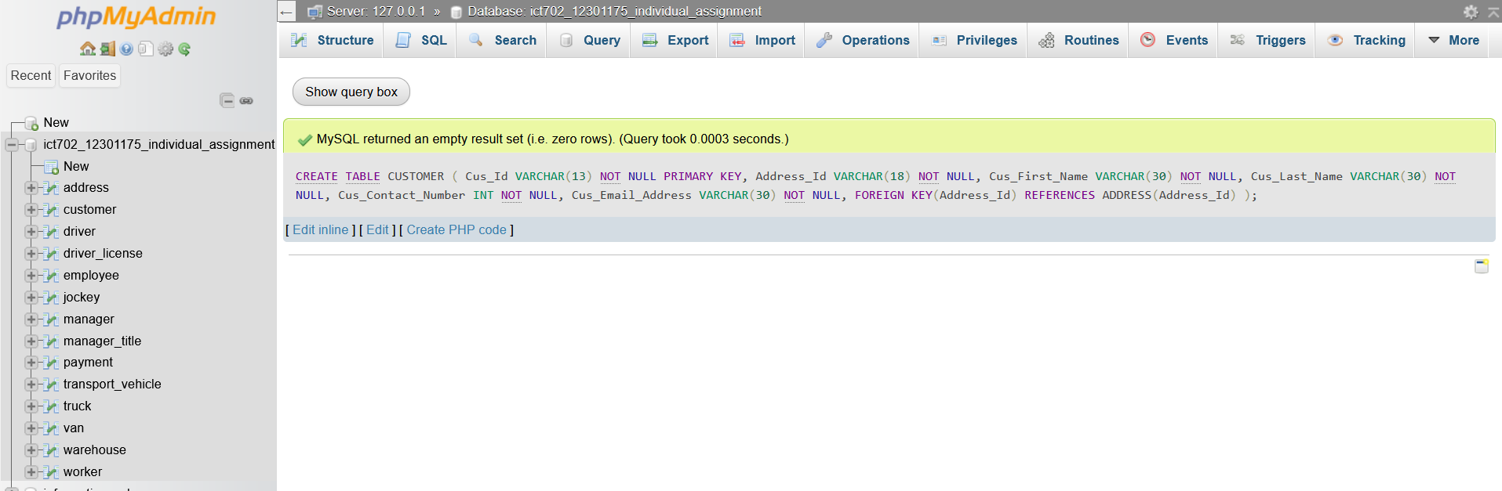

/*---- Table structure for table ‘INVOICE’---- */

CREATE TABLE INVOICE

(

Invoice_Id VARCHAR(13) NOT NULL PRIMARY KEY,

Cus_Id VARCHAR(13),

Invoice_Date DATE NOT NULL,

Invoice_Payment_Status Varchar(30) NOT NULL,

Payment_Id VARCHAR(13) NOT NULL,

FOREIGN KEY(Cus_Id) REFERENCES CUSTOMER(Cus_Id),

FOREIGN KEY(Payment_Id) REFERENCES PAYMENT(Payment_Id)

);

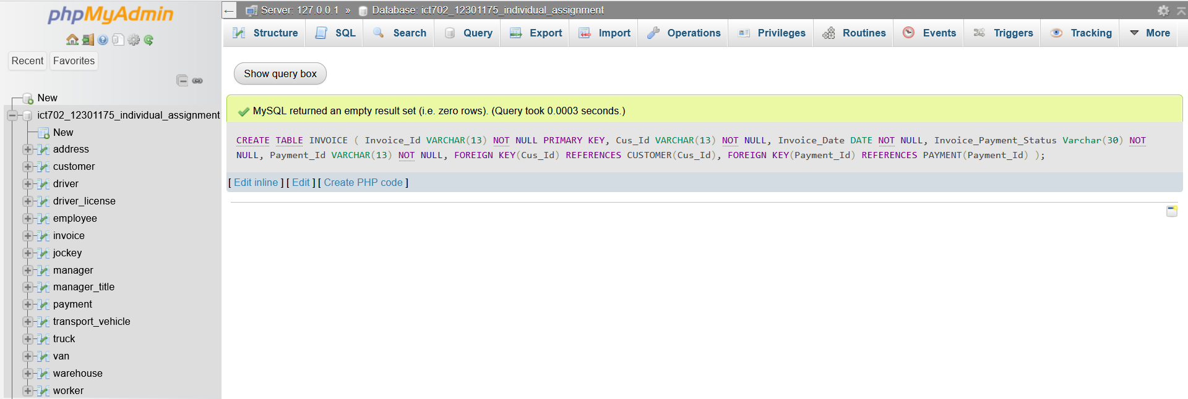

/*---- Table structure for table ‘PRODUCT’---- */

CREATE TABLE PRODUCT

(

Product_Id VARCHAR(10) NOT NULL PRIMARY KEY,

Wh_Id VARCHAR(7) NOT NULL,

Product_Description VARCHAR(50) NOT NULL,

Sold_Price Numeric(5,2) NOT NULL,

Product_Type_Code INT NOT NULL,

FOREIGN KEY(Wh_Id) REFERENCES WAREHOUSE(Wh_Id)

);

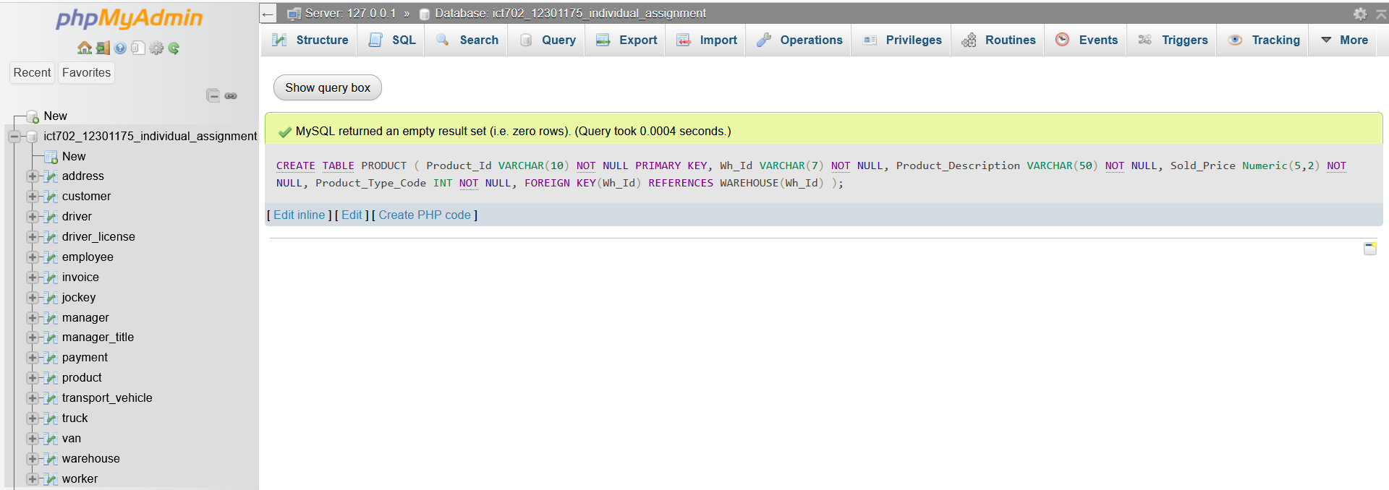

/*---- Table structure for table ‘LINE_ITEM’---- */

CREATE TABLE LINE_ITEM

(

Line_Item_Id VARCHAR(11) NOT NULL PRIMARY KEY,

Product_Id VARCHAR(10) NOT NULL,

Invoice_Id VARCHAR(13) NOT NULL,

Qty INT NOT NULL,

Line_Price NUMERIC(7,2) NOT NULL,

FOREIGN KEY(Product_Id) REFERENCES PRODUCT(Product_Id),

FOREIGN KEY(Invoice_Id) REFERENCES INVOICE(Invoice_Id)

);

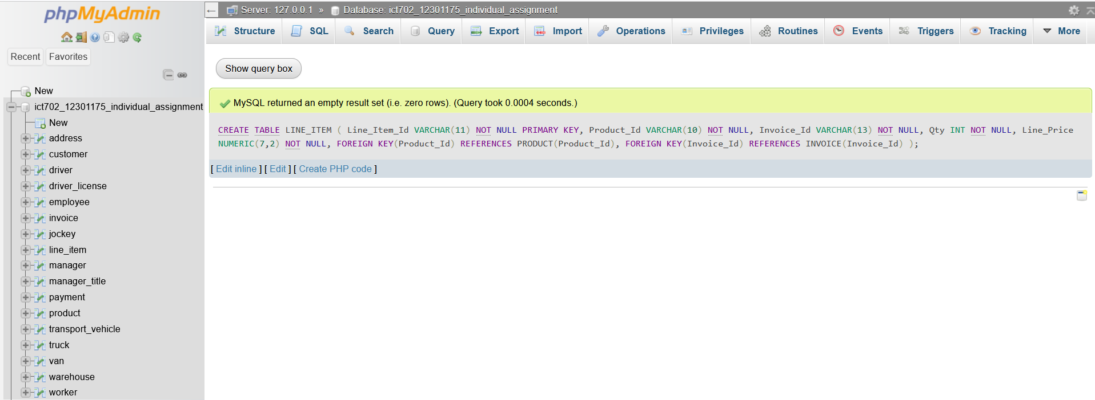

/*---- Table structure for table ‘DELIVERY_REQUEST’---- */

CREATE TABLE DELIVERY_REQUEST

(

Delivery_Id VARCHAR(12) NOT NULL PRIMARY KEY,

Request_Date DATE NOT NULL,

Requested_Delivery_Date DATE NOT NULL,

Actual_Delivery_Date DATE NOT NULL,

Delivery_Contact_Name VARCHAR(30) NOT NULL,

Delivery_Phone_Number INT NOT NULL,

Delivery_Instructions VARCHAR(200) NOT NULL,

Invoice_Id VARCHAR(13) NOT NULL,

Wh_Id VARCHAR(7) NOT NULL,

Address_Id VARCHAR(18) NOT NULL,

Cus_Id VARCHAR(13),

Emp_Id VARCHAR(8) NOT NULL,

Registration_Number VARCHAR(7) NOT NULL,

FOREIGN KEY(Invoice_Id) REFERENCES INVOICE(Invoice_Id),

FOREIGN KEY(Wh_Id) REFERENCES WAREHOUSE(Wh_Id),

FOREIGN KEY(Address_Id) REFERENCES ADDRESS(Address_Id),

FOREIGN KEY(Cus_Id) REFERENCES CUSTOMER(Cus_Id),

FOREIGN KEY(Emp_Id) REFERENCES EMPLOYEE(Emp_Id),

FOREIGN KEY(Registration_Number) REFERENCES TRANSPORT_VEHICLE(Registration_Number)

);

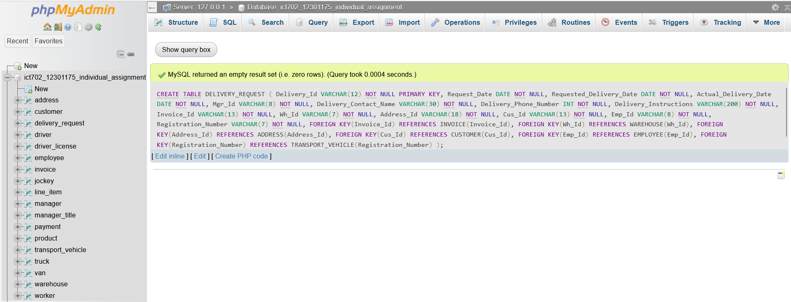

# 10.0 DML STATEMENTS

A set of SQL commands known as Data Manipulation Language (DML) is used to query, modify, add, and delete row-level data from database tables or views. DML can carry out operations like adding new rows, updating and removing existing rows, and combining tables (Juba and Volkov, 2019).

/*---- Dumping data for table ‘ADDRESS---- */

INSERT into ADDRESS VALUES

('157_ON_HD_NSW_2158', '157, Old Northern Road', 'Hills District', 'NSW', 2158),

('178_GR_C__QSL_4034', '178 Gympie Road', 'Carseldine', 'QSL', 4034),

('026_IC_R__NSW_2112', '26, Irvine Crescent', 'Ryde', 'NSW', 2112),

('004_BC_WH_VIC_3150', '4, Bimbadeen Court', 'Wheelers Hill', 'VIC', 3150),

('11A_HS_CP_NSW_2097', '11A, Heather Street', 'Collaroy Plateau', 'NSW', 2097),

('012_FS_NM_VIC_3051', '12, Fogarty Street', 'North Melbourne', 'VIC', 3051),

('018_KR_WP_NSW_2125', '18, Keelendi Road', 'West Pennant Hills', 'NSW', 2125);

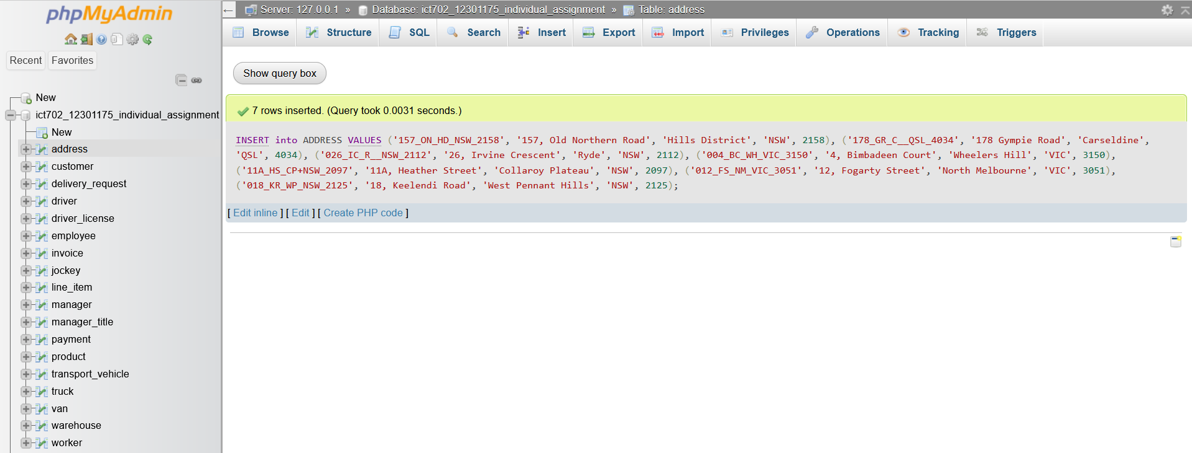

SELECT * FROM ADDRESS;

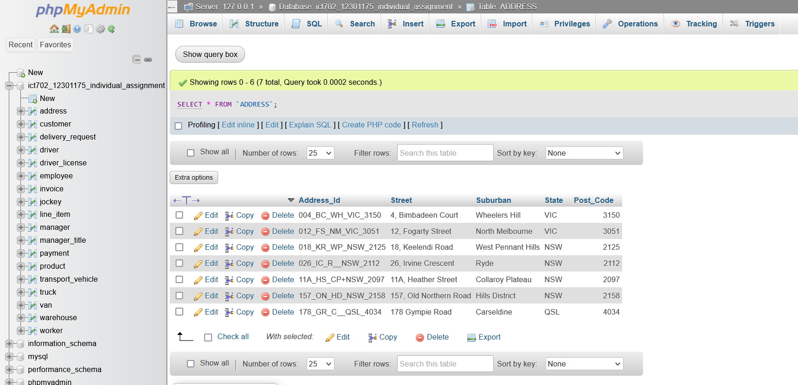

/*---- Dumping data for table ‘DRIVER_LICENSE’---- */

INSERT into DRIVER_LICENSE VALUES

(358562600, '2026-06-04'),

(358562601, '2025-03-10'),

(358562602, '2025-11-07'),

(358562603, '2026-04-22'),

(358562604, '2025-03-20'),

(358562605, '2025-09-09'),

(358562606, '2027-07-07'),

(358562607, '2026-10-02'),

(358562608, '2026-06-26'),

(358562609, '2025-03-10'),

(358562610, '2025-11-07'),

(358562611, '2026-04-22');

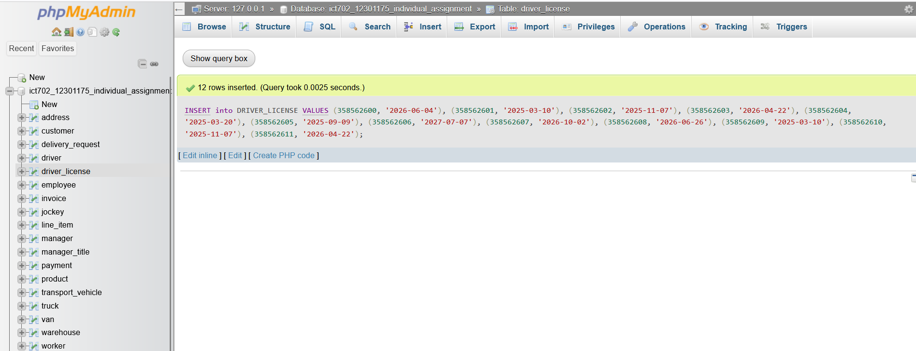

SELECT * FROM DRIVER_LICENSE;

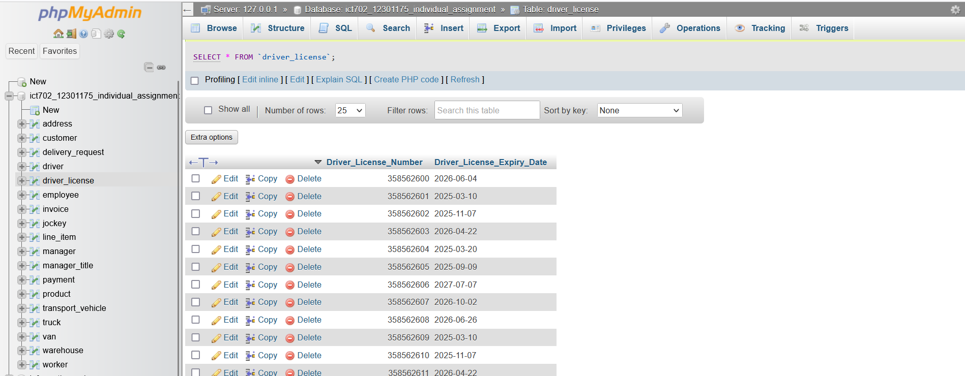

/*---- Dumping data for table ‘MANAGER_TITLE’ ---- */

INSERT into MANAGER_TITLE VALUES

('MGRNSW', 'MASTERSNSW', '2022-06-09'),

('MGRVIC', 'MASTERSVIC', '2023-07-22'),

('MGRQSL', 'MASTERSQSL', '2023-02-12');

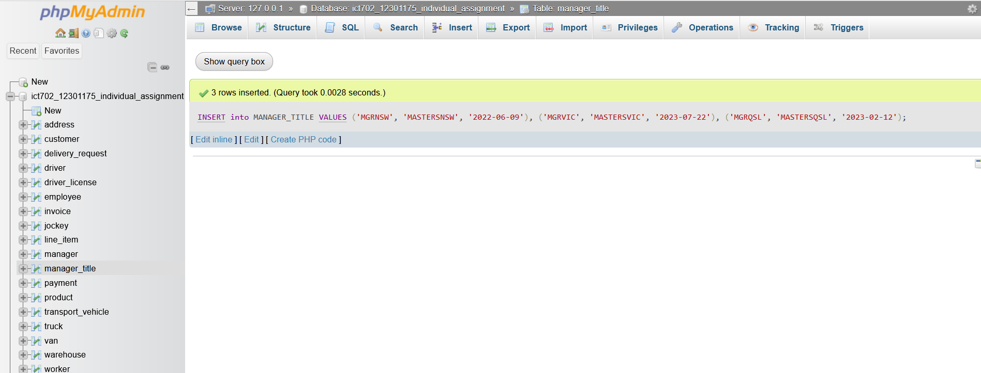

SELECT * FROM MANAGER_TITLE;

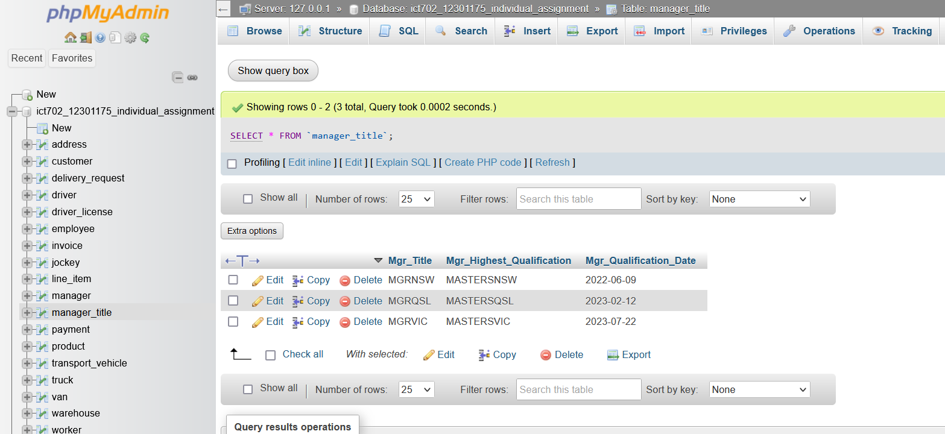

/*---- Dumping data for table ‘WAREHOUSE’ ---- */

INSERT into WAREHOUSE VALUES

('TOYNSW1', '157_ON_HD_NSW_2158', 'toynsw1@tfy.com.au', 552796245, 2400, 5, 10),

('TOYVIC1', '004_BC_WH_VIC_3150', 'toyvic1@tfy.com.au', 552796246, 2450, 6, 12),

('TOYQSL1', '178_GR_C__QSL_4034', 'toyqsl1@tfy.com.au', 552796247, 2500, 5, 14);

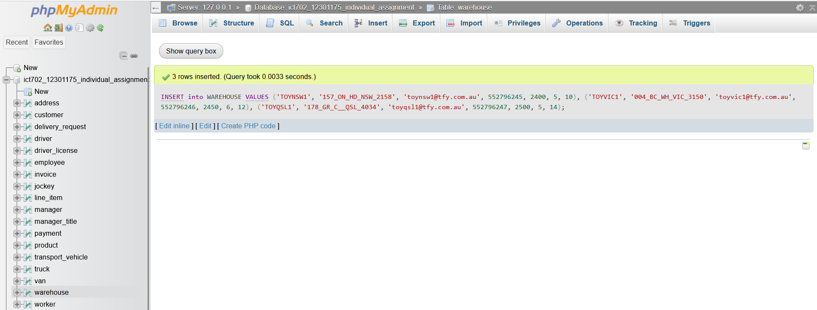

SELECT * FROM WAREHOUSE;

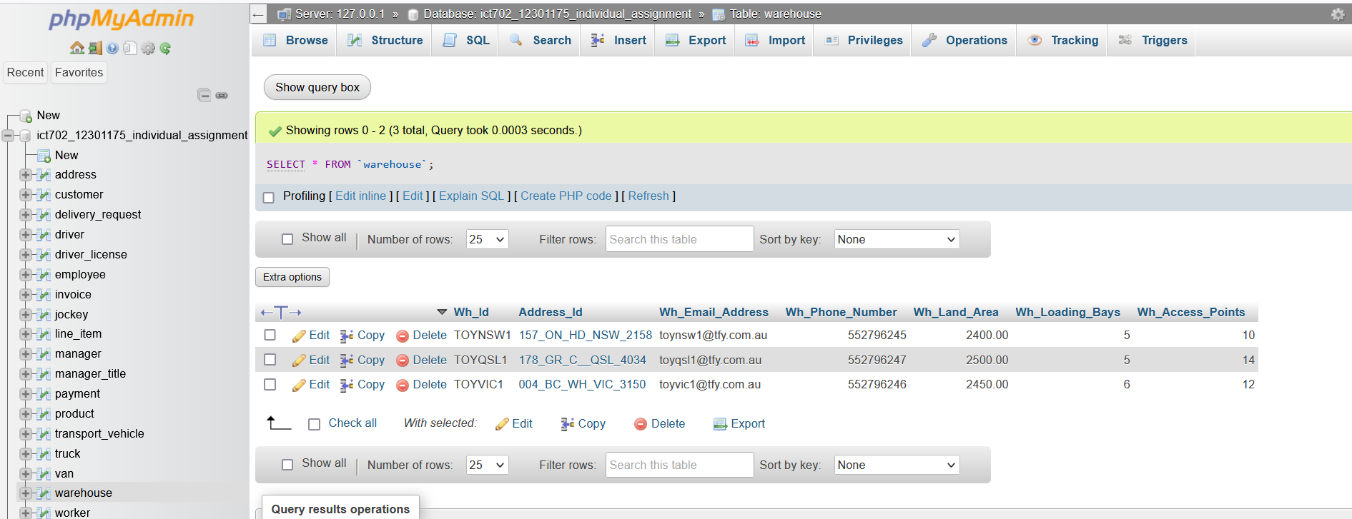

/*---- Dumping data for table ‘MANAGER’ ---- */

INSERT into MANAGER VALUES

('TFY00350', 'TOYNSW1', 'MGRNSW', 358562600, 'Caleigh', 'Stevie', 480527702, 'c.stevie@tfy.com.au', '2018-10-16', '2023-10-16'),

('TFY00352', 'TOYQSL1', 'MGRQSL', 358562602, 'Gabe', 'Adrian', 480527704, 'c.driscoll@tfy.com.au', '2021-06-30', '2026-06-30'),

('TFY00351', 'TOYVIC1', 'MGRVIC',358562601, 'Chase', 'Driscoll', 480527703, 'c.driscoll@tfy.com.au', '2023-01-04', '2028-01-04');

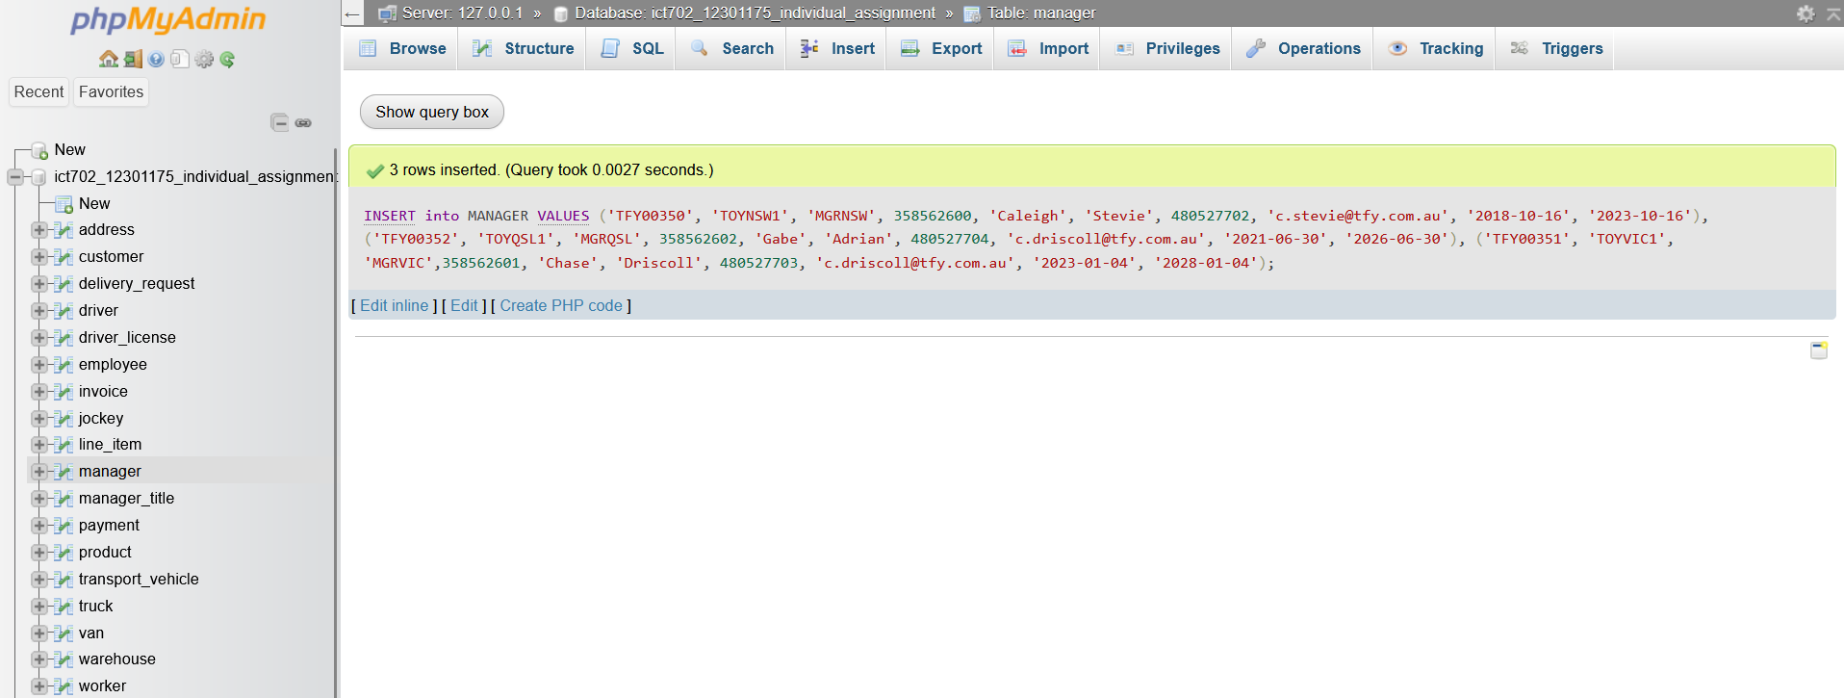

SELECT * FROM MANAGER;

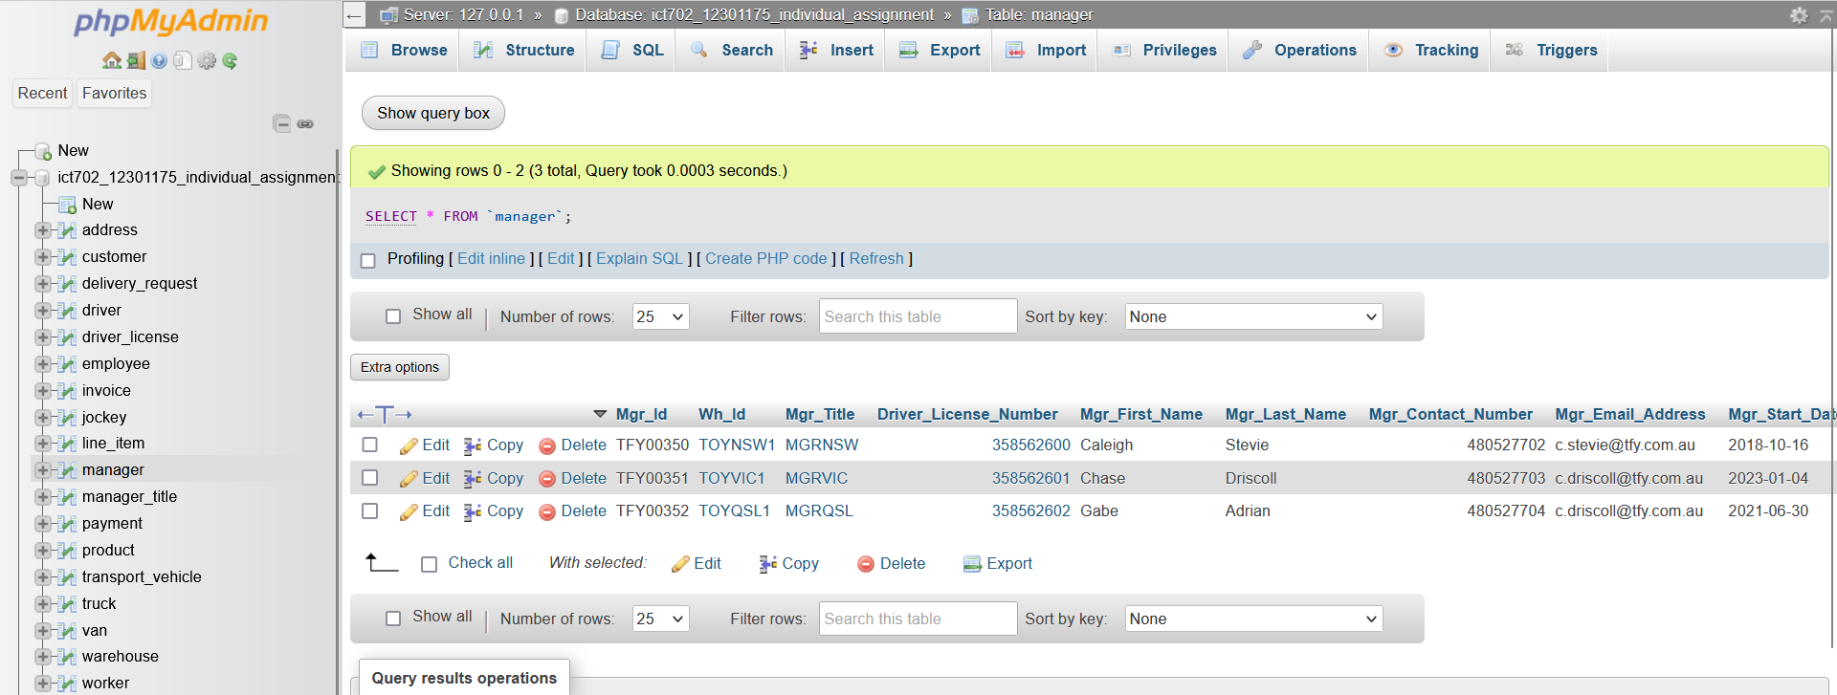

/*---- Dumping data for table ‘PAYMENT’ ---- */

INSERT into PAYMENT VALUES

('PAYTFY1000023', 'Card', 95.4),

('PAYTFY1000024', 'Card', 96.5),

('PAYTFY1000025', 'Card', 148.5);

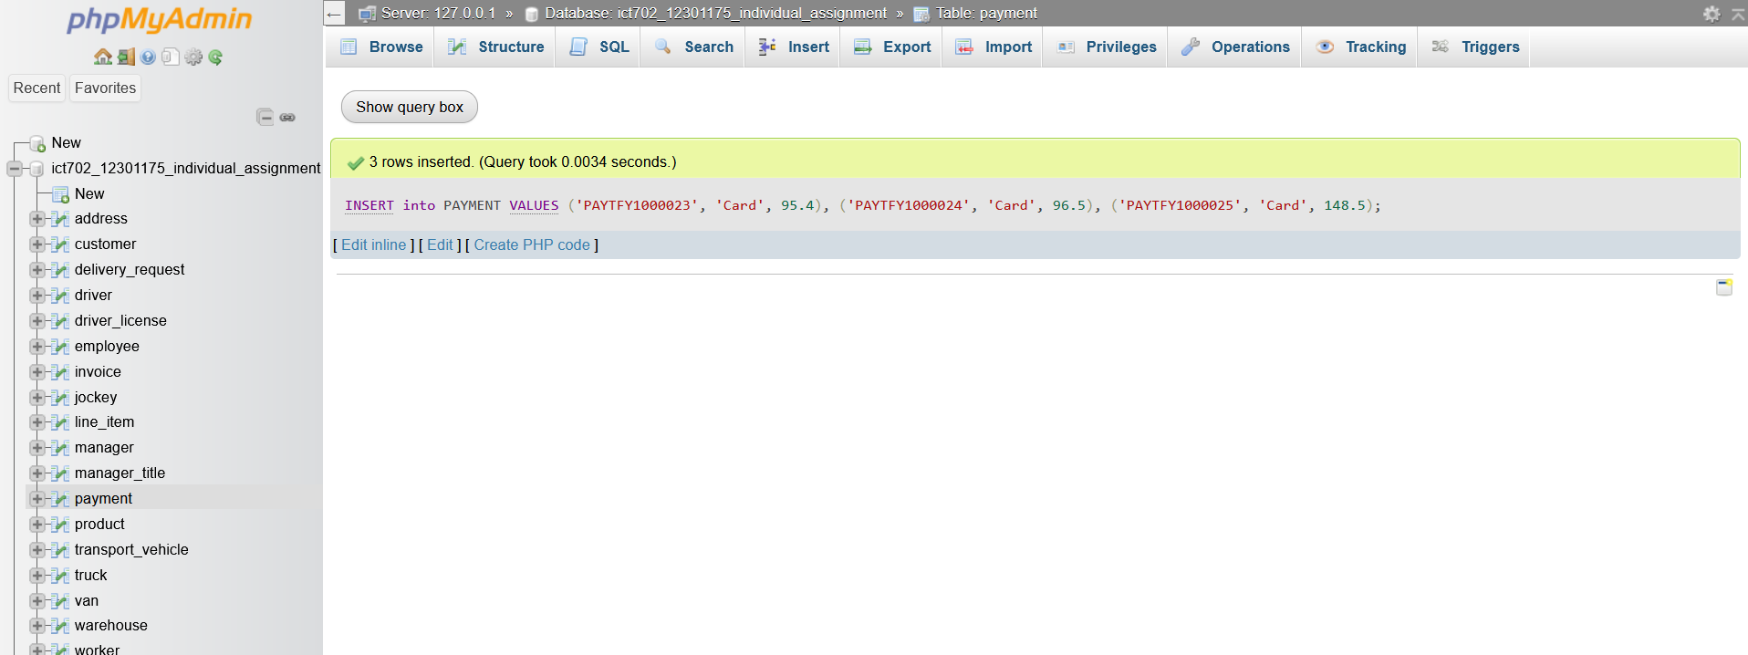

SELECT * FROM PAYMENT;

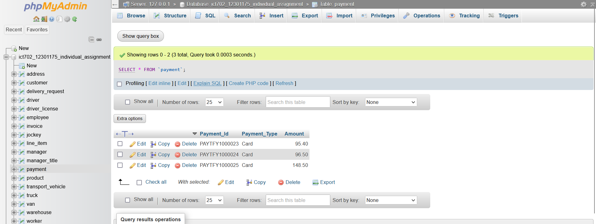

/*---- Dumping data for table ‘EMPLOYEE’ ---- */

INSERT into EMPLOYEE VALUES

('TFY01781', 'TOYNSW1', 'TFY00350', 358562603, 'Barnaby', 'Miles', 480527705, 'b.miles@tfy.com.au', '2019-05-12', '2024-05-12', 'Worker'),

('TFY01782', 'TOYNSW1', 'TFY00350', 358562604, 'Evan', 'Tolly', 480527706, 'e.tolly@tfy.com.au', '2021-10-09', '2026-10-09', 'Jockey'),

('TFY01783', 'TOYNSW1', 'TFY00350', 358562605, 'Promise', 'Meredith', 480527707, 'p.meredith@tfy.com.au', '2024-11-16', '2029-11-16', 'Driver'),

('TFY01784', 'TOYVIC1', 'TFY00351', 358562606, 'Rodger', 'Valentine', 480527708, 'r.valentine@tfy.com.au', '2018-11-04', '2023-11-04', 'Worker'),

('TFY01785', 'TOYVIC1', 'TFY00351', 358562607, 'Harland', 'Deacon', 480527709, 'h.deacon@tfy.com.au', '2019-02-11', '2024-02-11', 'Jockey'),

('TFY01786', 'TOYVIC1', 'TFY00351', 358562608, 'Karter', 'Faron', 480527710, 'k.faron@tfy.com.au', '2020-11-28', '2025-11-28', 'Driver'),

('TFY01787', 'TOYQSL1', 'TFY00352', 358562609, 'Sinclair', 'Ward', 480527711, 's.ward@tfy.com.au', '2022-03-27', '2027-03-27', 'Worker'),

('TFY01788', 'TOYQSL1', 'TFY00352', 358562610, 'Denny', 'Travers', 480527712, 'd.travers@tfy.com.au', '2023-12-21', '2028-12-21', 'Jockey'),

('TFY01789', 'TOYQSL1', 'TFY00352', 358562611, 'Vyvyan', 'Jackie', 480527713, 'v.jackie@tfy.com.au', '2024-11-16', '2029-11-16', 'Driver');

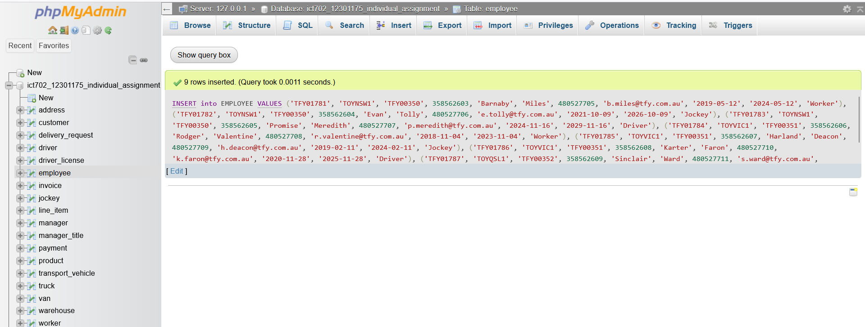

SELECT * FROM EMPLOYEE;

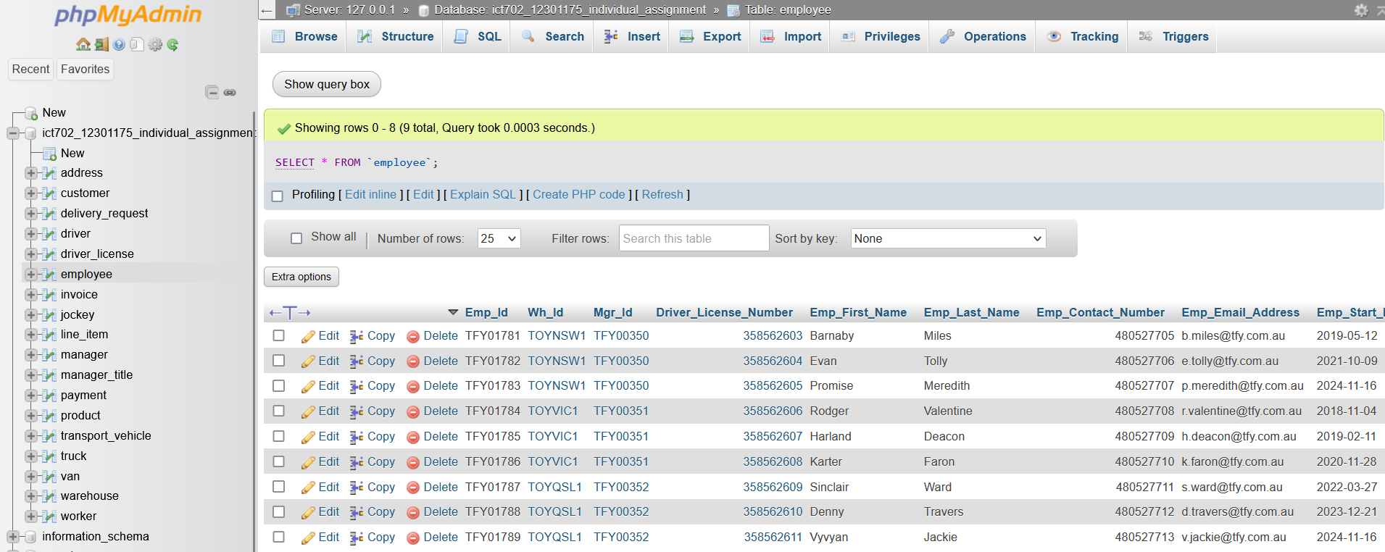

/*---- Dumping data for table ‘WORKER’ ---- */

INSERT into WORKER VALUES

('TFY01781', 'HRW000100', '2027-09-30'),

('TFY01784', 'HRW000101', '2025-10-15'),

('TFY01787', 'HRW000102', '2026-03-31');

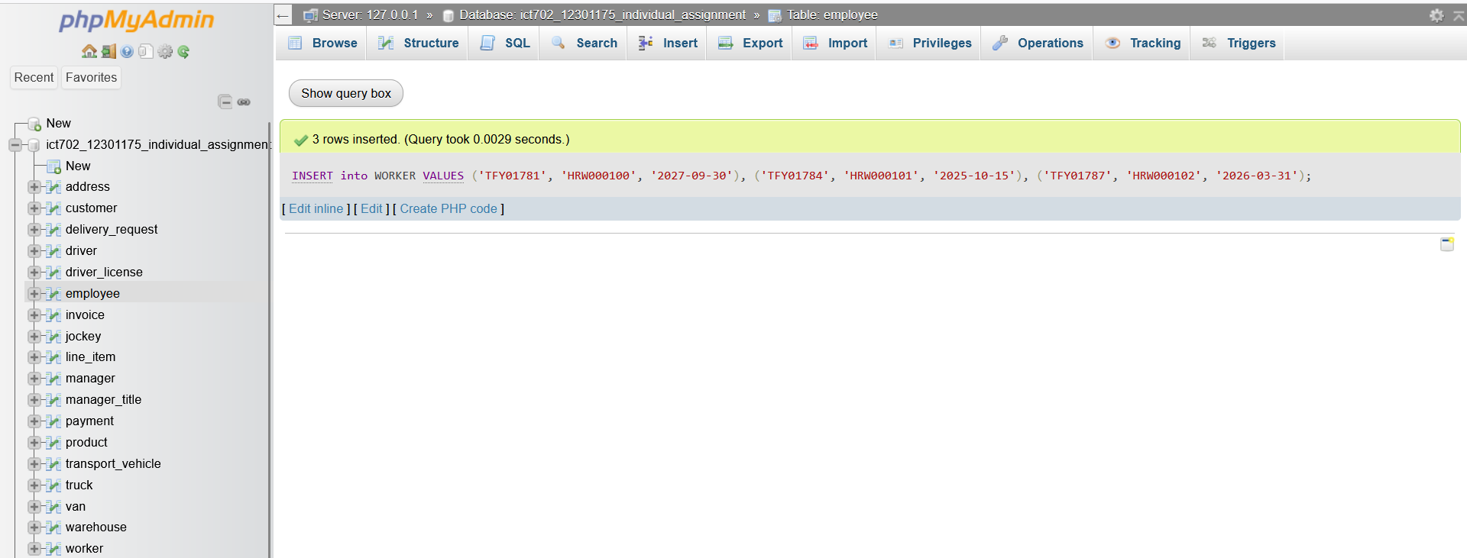

SELECT * FROM WORKER;

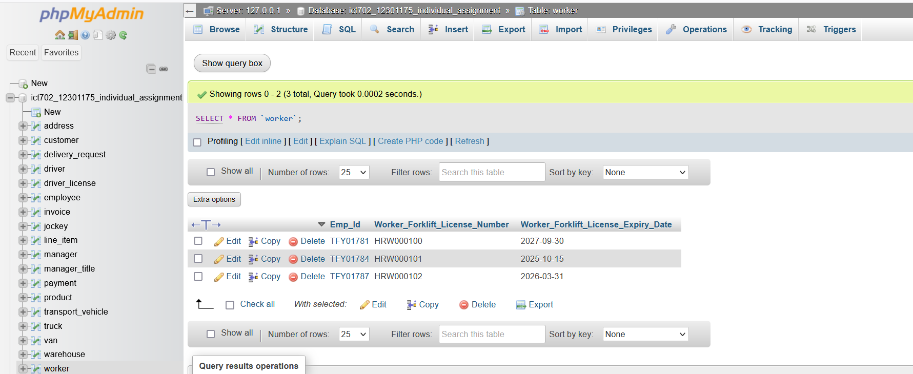

/*---- Dumping data for table ‘DRIVER ---- */

INSERT into DRIVER VALUES

('TFY01783', 'T1', '2027-09-30'),

('TFY01786', 'T1', '2025-10-15'),

('TFY01789', 'T1', '2026-03-31');

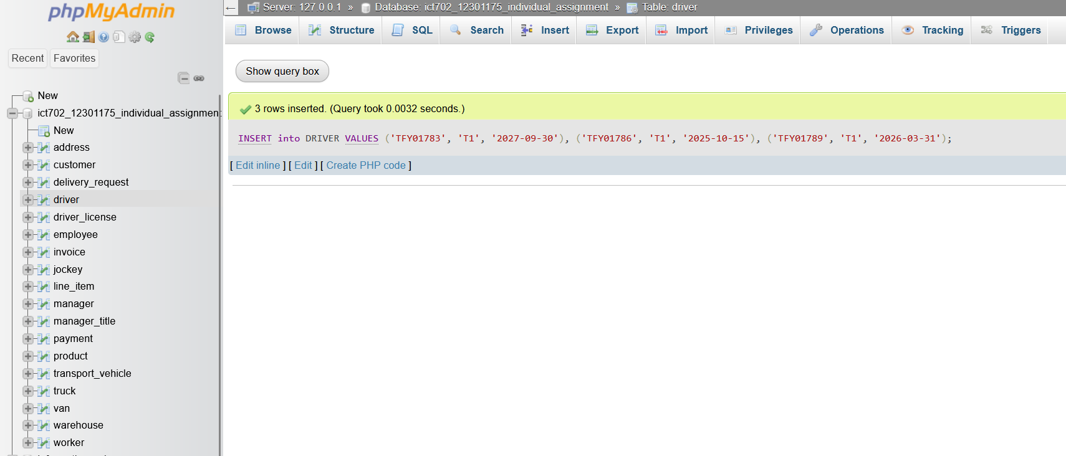

SELECT * FROM DRIVER;

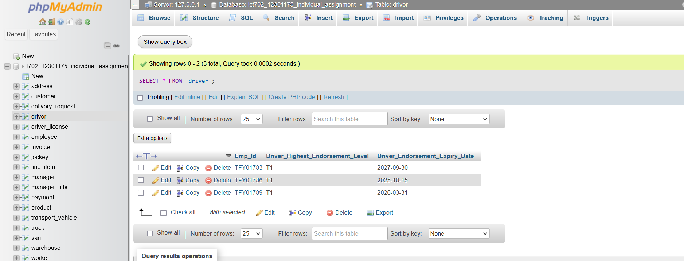

/*---- Dumping data for table ‘JOCKEY’ ---- */

INSERT into JOCKEY VALUES

('TFY01782', 'RGR40218', '2020'),

('TFY01785', 'RGR40219', '2021'),

('TFY01788', 'RGR40220', '2022');

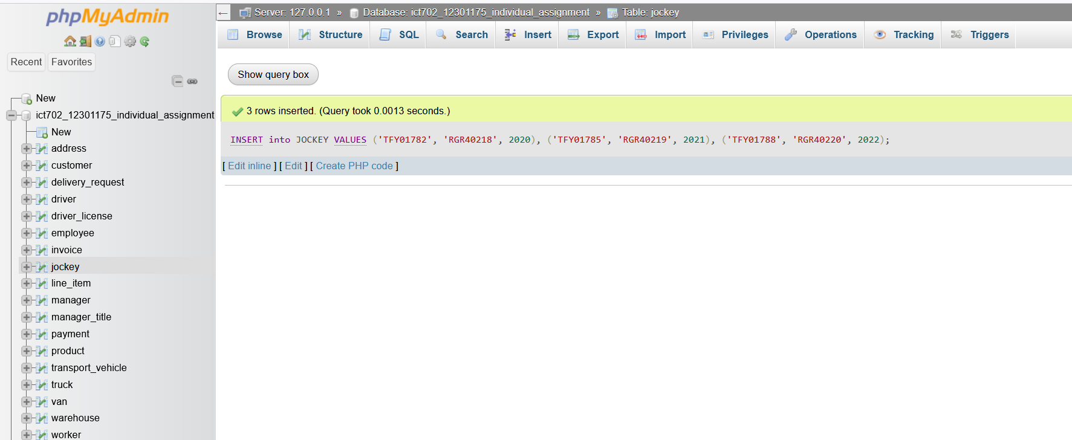

SELECT * FROM JOCKEY;

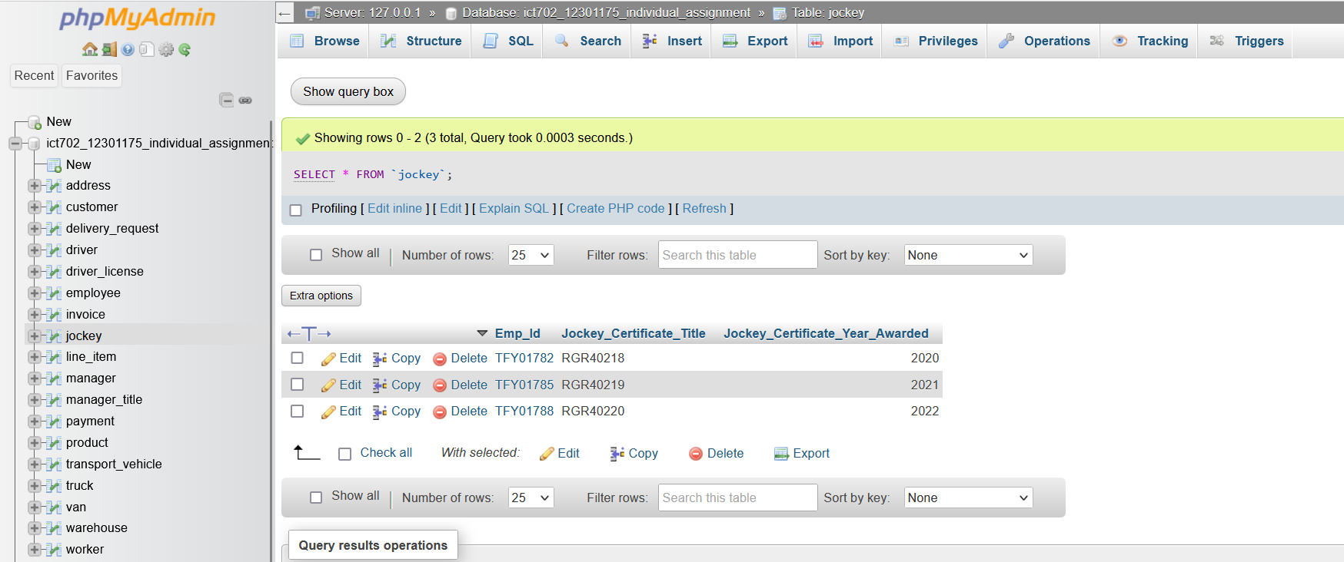

/*---- Dumping data for table ‘TRANSPORT_VEHCILE’ ---- */

INSERT into TRANSPORT_VEHICLE VALUES

('TEBY50Y', 'TOYNSW1', 'TFY01783', 2, 907, 3500, 2593, 40, 2, 2.4, 4, 'Out', 'Truck'),

('VEBY49Z', 'TOYVIC1', 'TFY01786', 2, 600, 3000, 2400, 15, 1.3, 1.5, 2, 'In', 'Van'),

('TEBY48A', 'TOYQSL1', 'TFY01789', 2, 907, 3500, 2593, 40, 2, 2.4, 4, 'Out', 'Truck'),

('VEBY47B', 'TOYNSW1', 'TFY01783', 2, 600, 3000, 2400, 15, 1.3, 1.5, 2, 'In', 'Van'),

('TEBY46C', 'TOYVIC1', 'TFY01786', 2, 907, 3500, 2593, 40, 2, 2.4, 4, 'Out', 'Truck'),

('VEBY45D', 'TOYQSL1', 'TFY01789', 2, 600, 3000, 2400, 15, 1.3, 1.5, 2, 'In', 'Van');

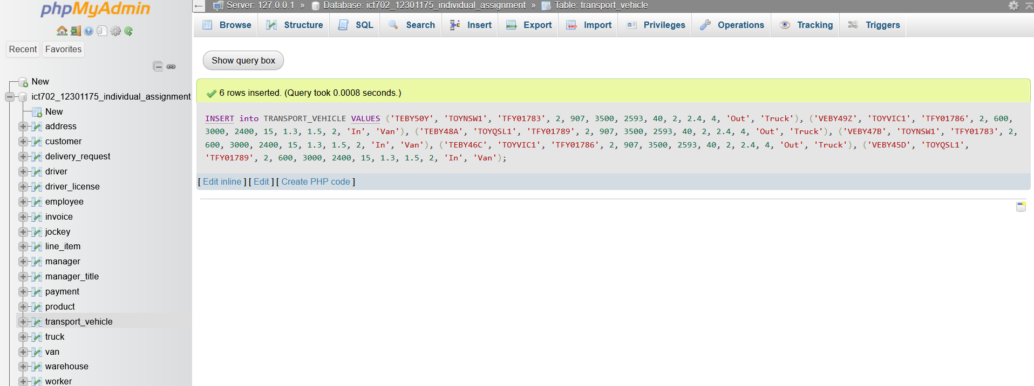

SELECT * FROM TRANSPORT_VEHICLE;

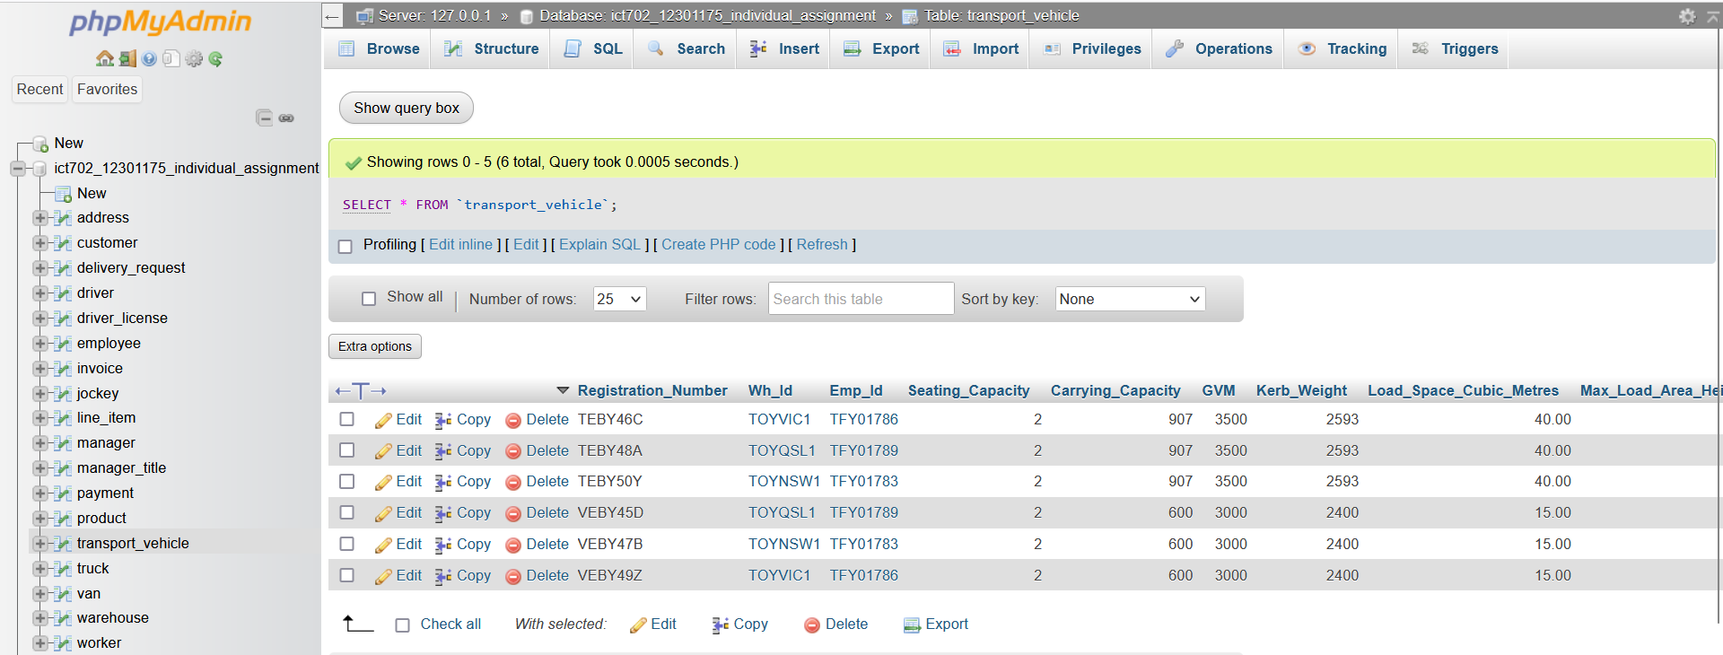

/*---- Dumping data for table ‘VAN’ ---- */

INSERT into VAN VALUES

('VEBY49Z', 'VANLCPCBVIC1100237', 'FORDTRANSIT2022-003', 2022),

('VEBY47B', 'VANLCPCBNSW1100238', 'FORDTRANSIT2022-003', 2022),

('VEBY45D', 'VANLCPCBQSL1100239', 'FORDTRANSIT2022-003', 2022);

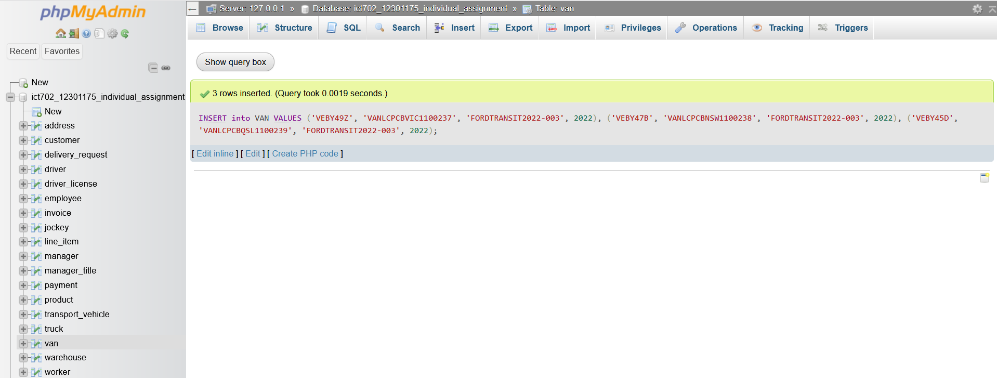

SELECT * FROM VAN;

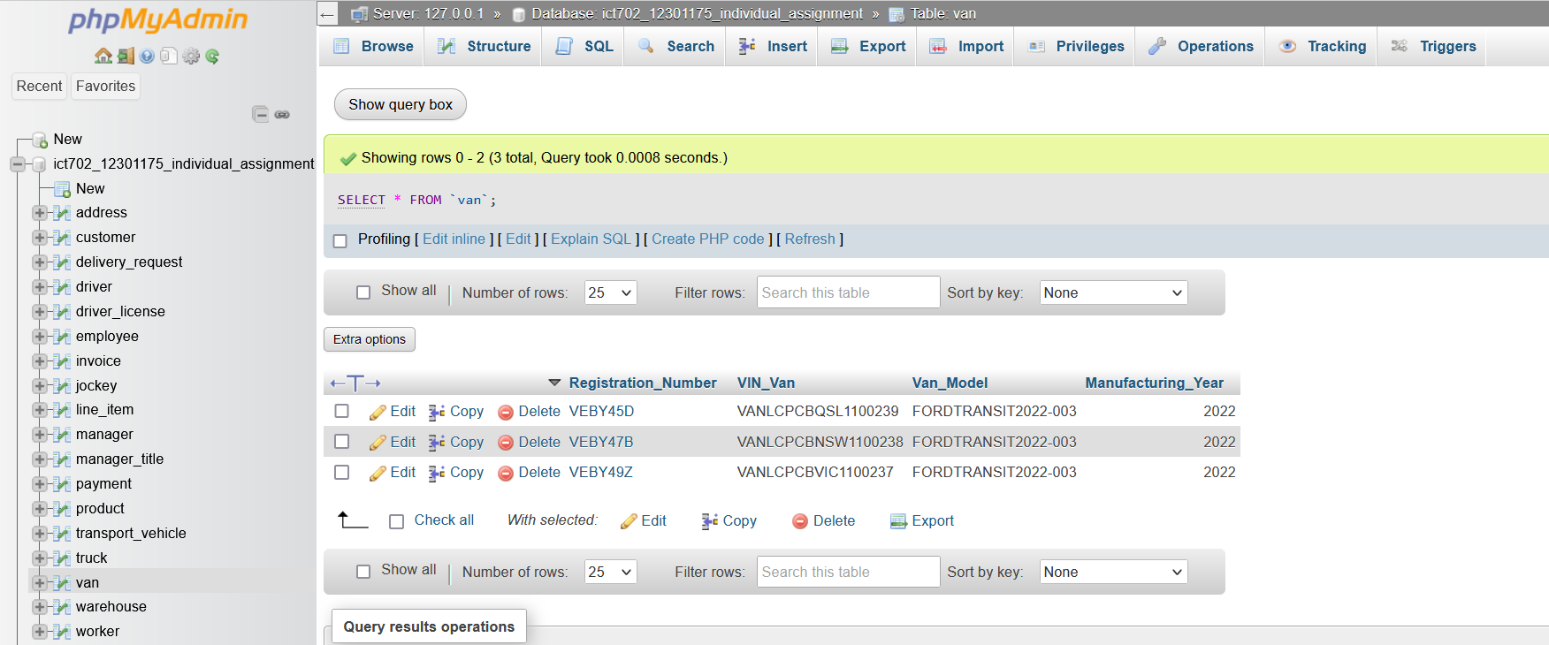

/*---- Dumping data for table ‘TRUCK’ ---- */

INSERT into TRUCK VALUES

('TEBY46C', 'TRULCPCBVIC1104575', 'ISUZUNSERIES2022-004', 2022),

('TEBY50Y', 'TRULCPCBNSW1104576', 'ISUZUNSERIES2022-005', 2022),

('TEBY48A', 'TRULCPCBQSL1104577', 'ISUZUNSERIES2022-006', 2022);

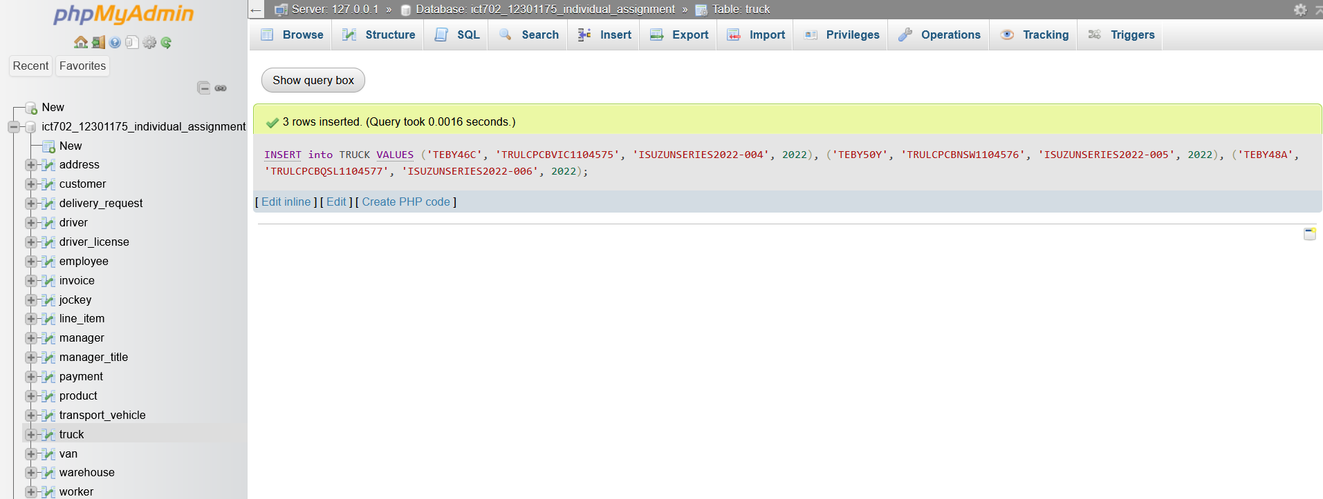

SELECT * FROM TRUCK;

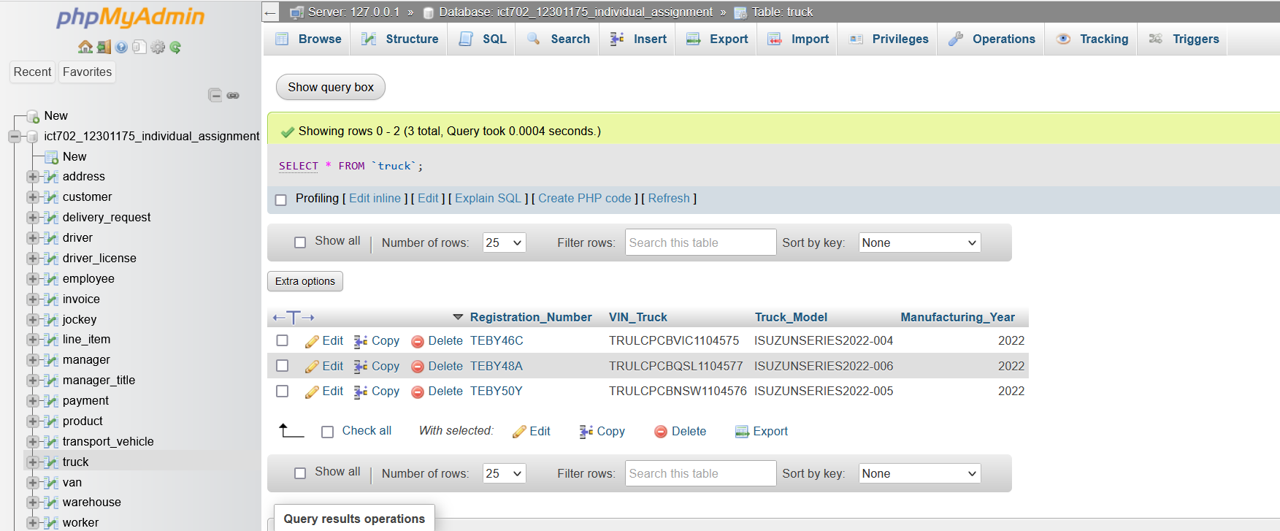

/*---- Dumping data for table ‘CUSTOMER’ ---- */

INSERT into CUSTOMER VALUES

('CUS0123901457', '026_IC_R__NSW_2112', 'Lauren', 'Geena', 0226782583, 'l.geena@customer.com.au'),

('CUS0123901458', '11A_HS_CP_NSW_2097', 'Em', 'Scarlett', 0226782584, 'e.scarlett@customer.com.au'),

('CUS0123901459', '012_FS_NM_VIC_3051', 'Ophelia', 'Isabel', 0226782585, 'o.isabel@customer.com.au');

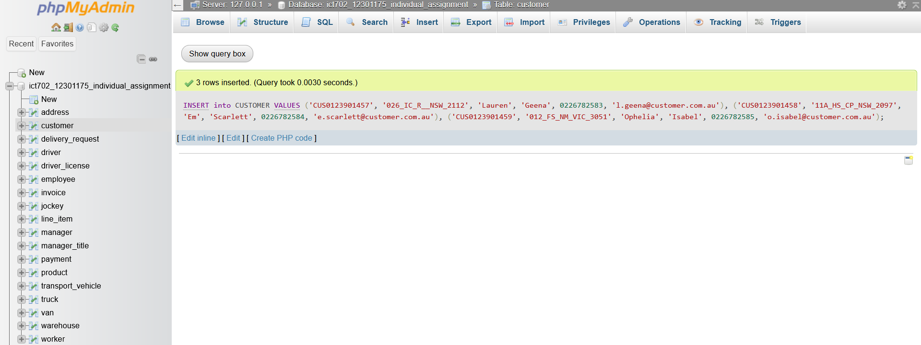

SELECT * FROM CUSTOMER

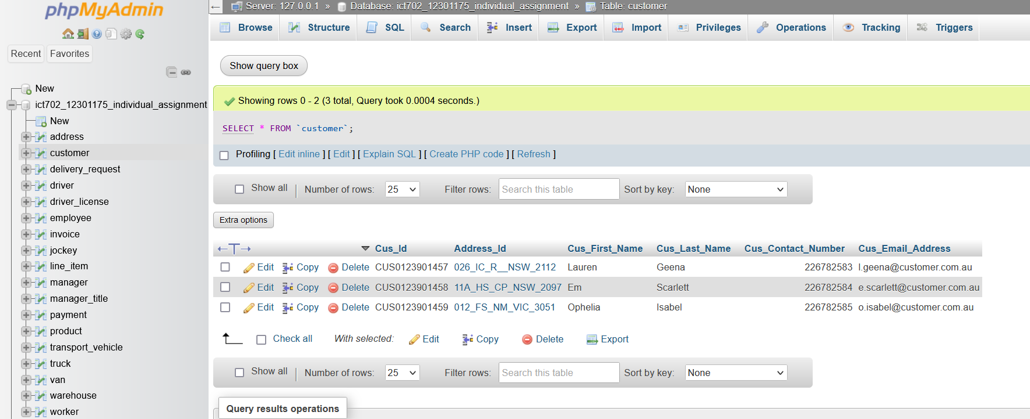

/*---- Dumping data for table ‘INVOICE’ ---- */

INSERT into INVOICE VALUES

('INV123014921A', 'CUS0123901457', '2023-09-06', 'Payed', 'PAYTFY1000023'),

('INV123014922B', 'CUS0123901458', '2023-09-07', 'Payed', 'PAYTFY1000024'),

('INV123014923C', 'CUS0123901459', '2023-09-08', 'Payed', 'PAYTFY1000025');

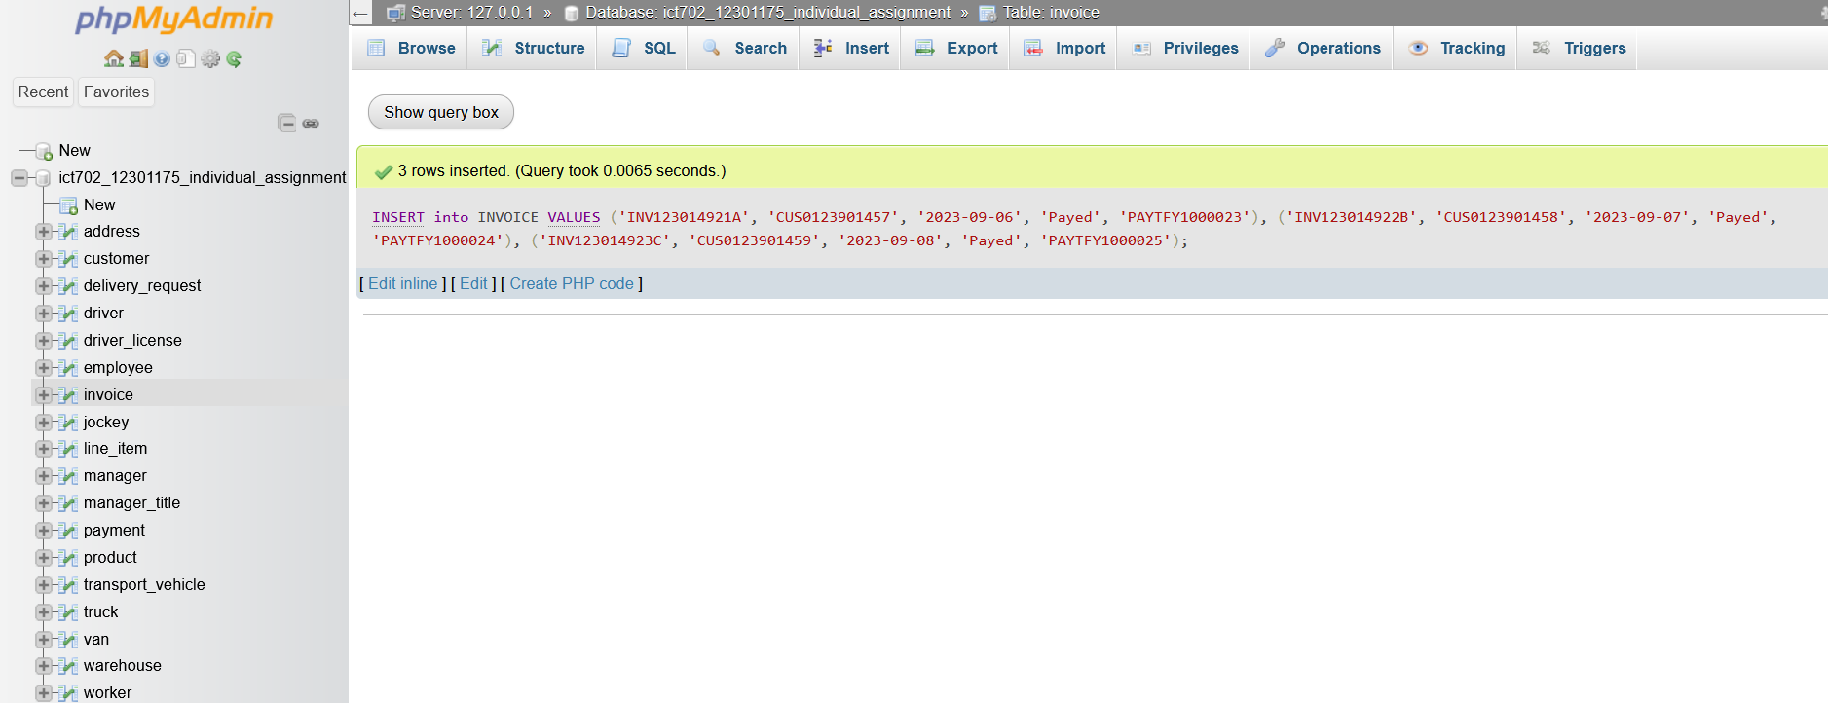

SELECT * FROM INVOICE;

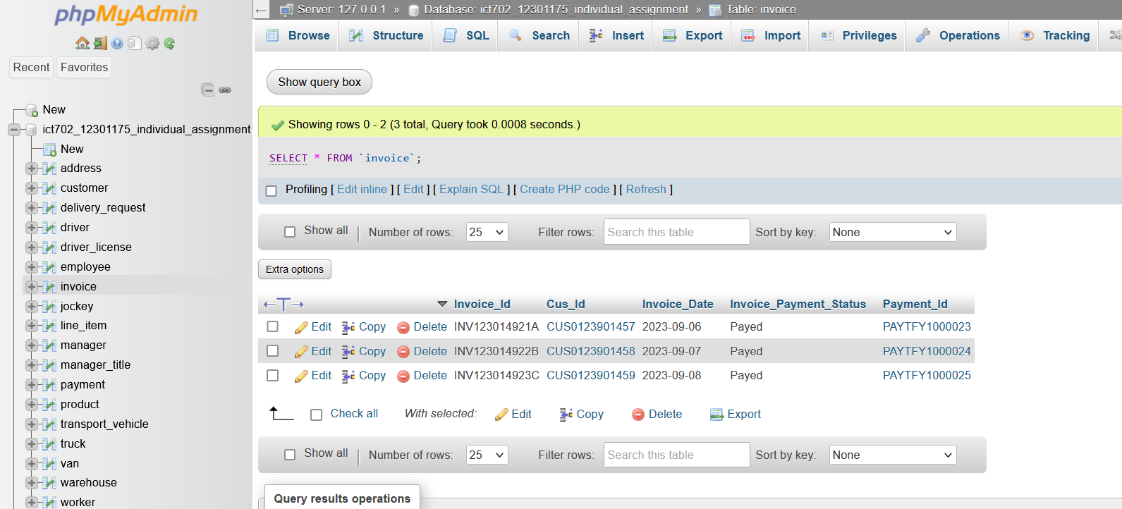

/*---- Dumping data for table ‘PRODUCT’ ---- */

INSERT into PRODUCT VALUES

('PRO230957A', 'TOYNSW1', 'Big Bear', 23.85, 1234567890),

('PRO230958B', 'TOYVIC1', 'Red Bike', 48.25, 1234567891),

('PRO230959C', 'TOYQSL1', 'Blue Bike', 49.50, 1234567892);

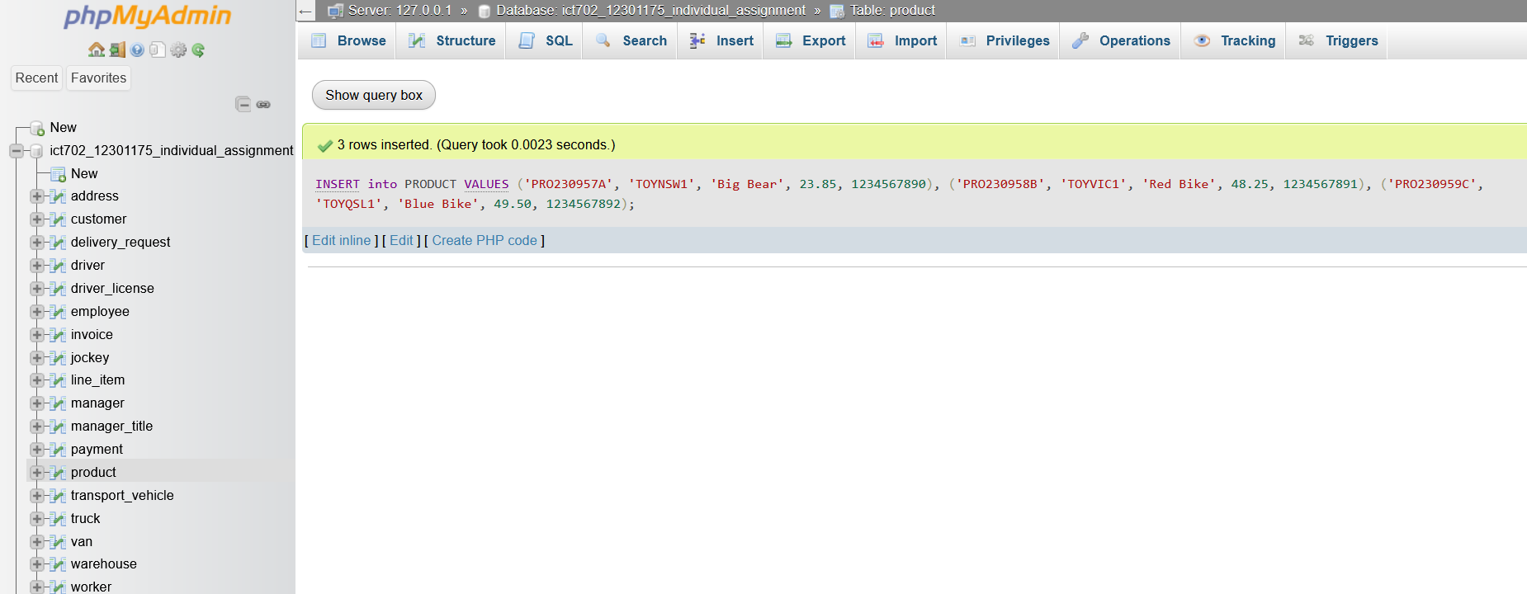

SELECT * FROM PRODUCT;

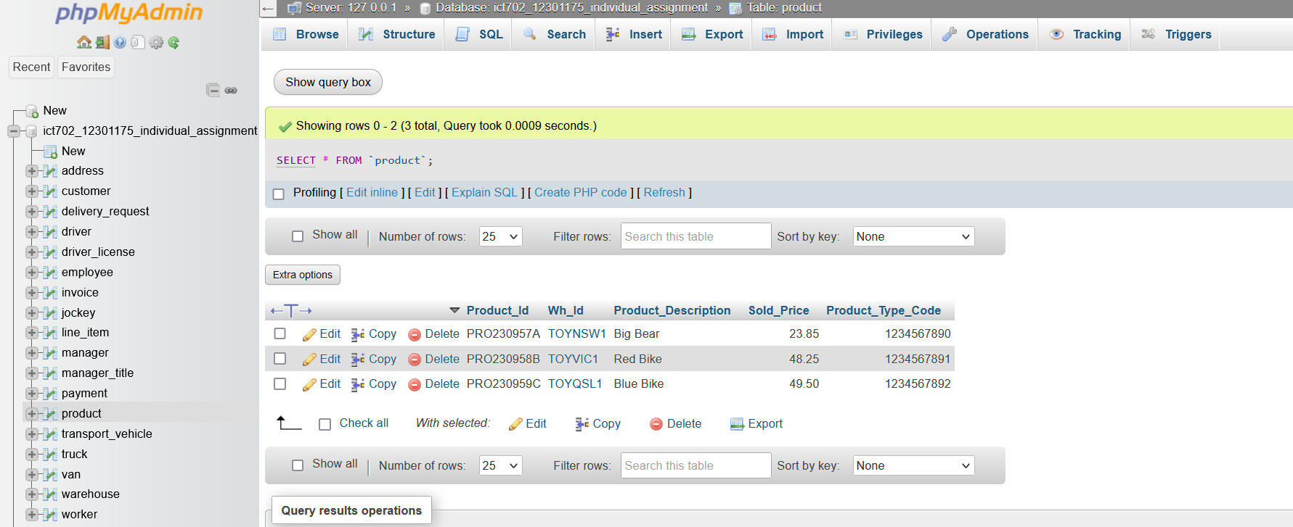

/*---- Dumping data for table ‘LINE_ITEM’ ---- */

INSERT into LINE_ITEM VALUES

('LINSW000001', 'PRO230957A', 'INV123014921A', 4, 95.4),

('LINSW000002', 'PRO230959C', 'INV123014922B', 2, 96.5),

('LIVIC000001', 'PRO230958B', 'INV123014922B', 3, 148.5);

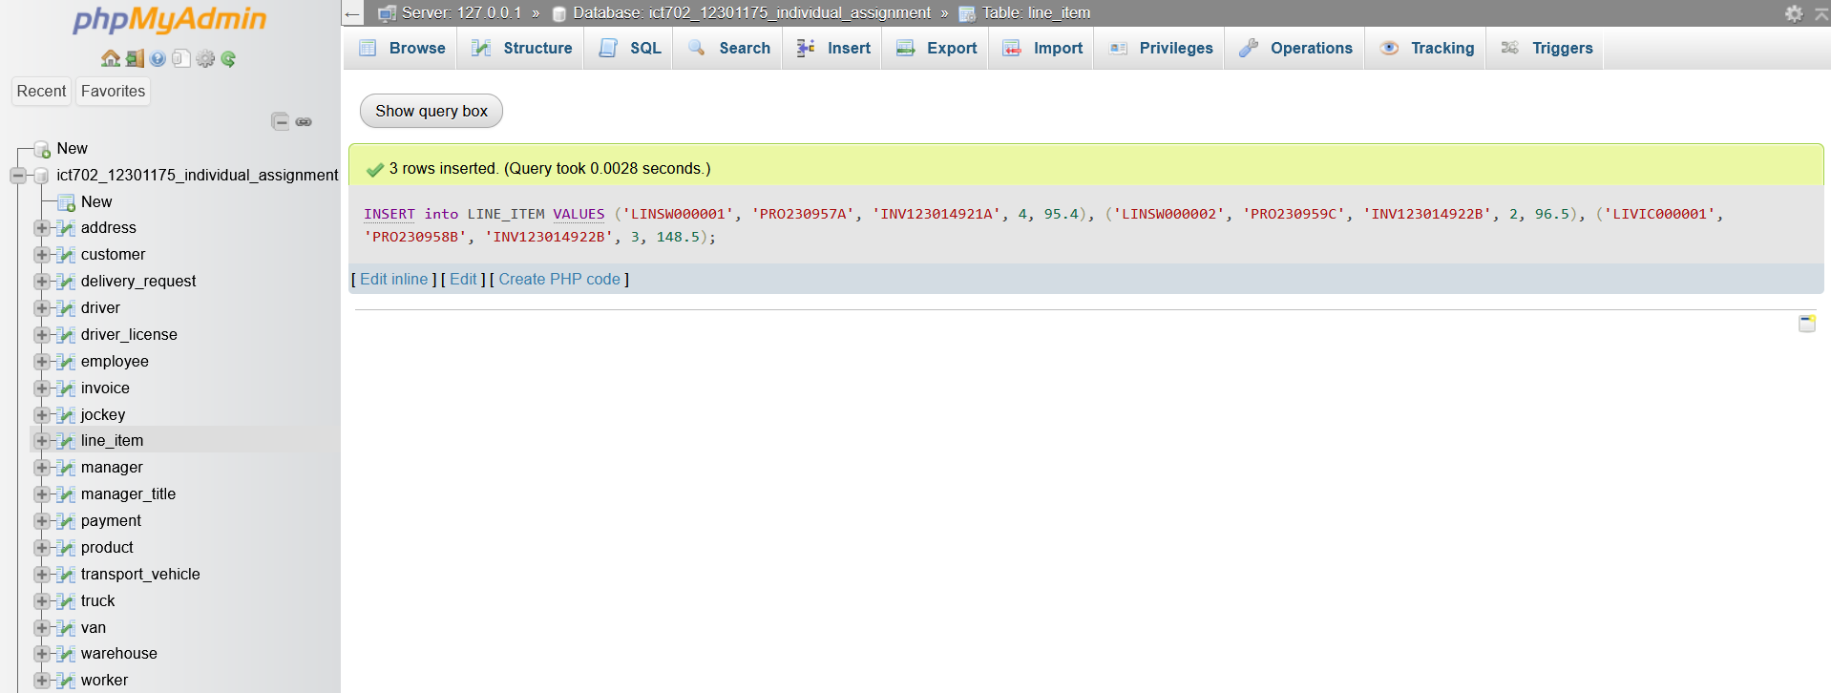

SELECT * FROM LINE_ITEM;

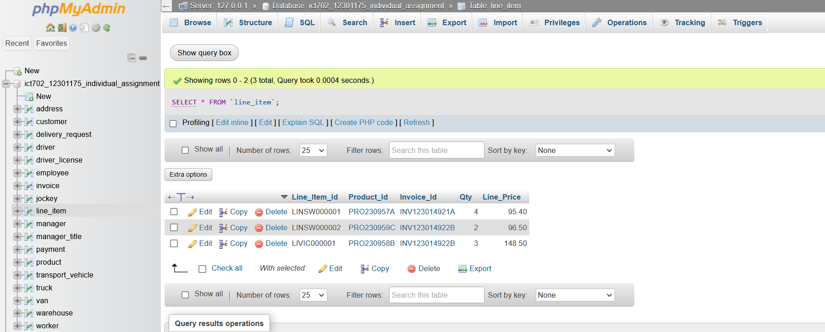

/*---- Dumping data for table ‘DELIVERY_REQUEST’ ---- */

INSERT into DELIVERY_REQUEST VALUES

('DLNSW0104579', '2023-09-06', '2023-09-13', '2023-09-14', 'Lauren Geena', 0226782583, 'Put beside the mail box.', 'INV123014921A', 'TOYNSW1', '026_IC_R__NSW_2112', 'CUS0123901457', 'TFY01782', 'TEBY50Y'),

('DLNSW0104580', '2023-09-07', '2023-09-14', '2023-09-13', 'Maybelle Zeb', 0226783457, 'Drop by the front door.', 'INV123014922B', 'TOYNSW1', '018_KR_WP_NSW_2125', 'CUS0123901458', 'TFY01782', 'TEBY50Y'),

('DLVIC0104590', '2023-09-08', '2023-09-15', '2023-09-15', 'Opelia Isabel', 0226783585, 'Drop by the front door.', 'INV123014922B', 'TOYVIC1', '012_FS_NM_VIC_3051', 'CUS0123901458', 'TFY01785', 'TEBY46C');

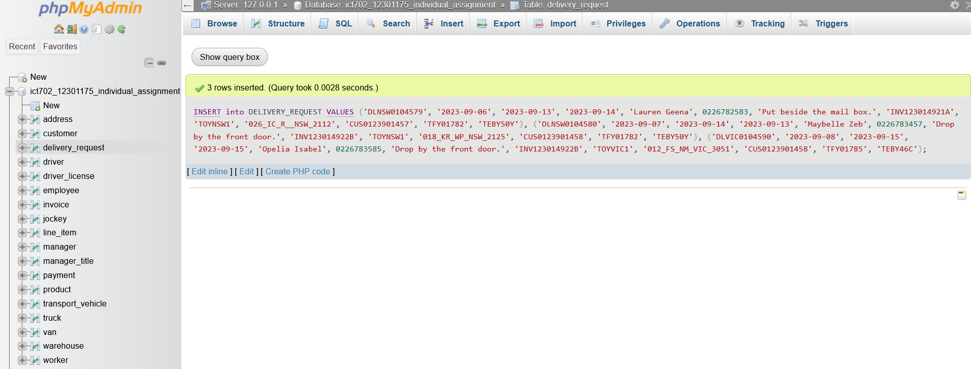

SELECT * FROM DELIVERY_REQUEST;

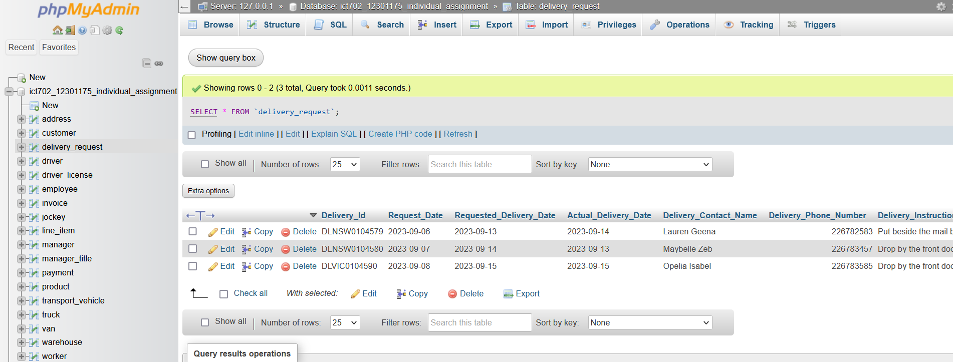

# 11.0 REFERENCES

Amin, M., Romney, G.W., Dey, P. and Sinha, B., 2019. Teaching relational database normalization in an innovative way. Journal of Computing Sciences in Colleges, 35(2), pp.48-56.

Harrington, J.L., 2016. Relational database design and implementation. Morgan Kaufmann.

Herrick, R., McKay, M., Olsen, T., Horton, W., Florida, M., Moore, C.J. and Marcus, D.S., 2014. Data dictionary services in XNAT and the Human Connectome Project. Frontiers in neuroinformatics, 8, p.65.

Juba, S. and Volkov, A., 2019. Learning PostgreSQL 11: A beginner's guide to building high-performance PostgreSQL database solutions. Packt Publishing Ltd.

Juba, S., Vannahme, A. and Volkov, A., 2015. Learning PostgreSQL. Packt Publishing Ltd.

Liddle, S.W., Embley, D.W. and Woodfield, S.N., 1993. Cardinality constraints in semantic data models. Data & Knowledge Engineering, 11(3), pp.235-270.